engineering geometry systems
FeatureCAM
2005
FeatureMILL 3D Fundamentals
Student
Training Guide
FeatureCAm – featuremill 3D Fundamentals
Student Training Guide
© 2005 Engineering Geometry Systems
275 East South Temple • Suite 305
Phone 888.393.6455 • Fax 801.575.5017
Table of Contents

Chapter 1 – Getting Started 3
Before You Start 3
Get It Going 3
New Part Document Wizard 3
New File 4
Chapter 2 – Introduction to Solid Modeling 5
Class Follow-Along 6
Creating a New Part 6
Creating a Base Solid 6
Adding Material with Extrude 7
Cutting Material with Extrude 7
Adding Fillets 8
Shelling the Part 8
Shelling the Part 9
Chapter 3 – Modeling 10
Creating Solids 10
Solids Wizard 10
Solids from Curves 12
Shape Modifiers 13
Solids from Surfaces/Primitives 14
Manufacturing 15
Creating Basic Surfaces 16
Flat 16
Chapter 4 – Modeling Exercise 17
Hair Dryer 17
Handle 18
Fan Area 20
Filleting 21
Filleting 22
Shell 25
Core and Cavity Mold 26
Making Toolpaths 26
Chapter 5 – Importing Files 28
Import/export options 28
Importing IGES files 29
IGES export 30
Importing DWG and DXF files 30
Chapter 6 Manufacturing Features 32
Surface Milling Feature 32
Dimensions tab 32
3D location tab 33
3D Process tab 33
machining side tab 34
Solution Sheet 34
3D Groove 35
Exercise 35
Chapter 7 - Manufacturing Operations 36
The flow of 3D milling 36
one, two three and your out 36
projection milling methods 37
parallel 39
Spiral 39
Spiral boundary 40
Spiral out 41
Spiral in 41
Radial in or out 42
Isoline milling method 43
plunge milling method 44
Z-level milling method 44
Clean up or clean out 44
remachining 44
pencil 44
Solution Sheet 45
Recommended Machining Strategies 47
Roughing Well-trimmed Models 47
Roughing Sloppy Data or Untrimmed Models 47
Finishing Nearly Vertical Walls 48
Finishing Large Imported Files 48
Finishing Large Imported Part with Irregular Shape 49
Finishing Smaller Models Created in FeatureMILL 49
Finishing bowls 49
3D Tools tab 50
3D Milling tab and Manufacturing attributes 50

Chapter 1 – Getting Started
Chapter
1
This course is designed to teach you the fundamentals of using FeatureCAM to model and simulate the machining of three dimensional parts.

Before You Start
this course assumes that you have a fundamental knowledge of the Windows operating system. That is to say that you are familiar with the mouse, Windows desktop and Start menu, and can navigate the hard drive with either My Computer or Windows Explorer.
Before you begin this course, it is recommended that you are familiar with the FeatureCAM interface and have gone through the tutorials in the FeatureCAM Getting Started Guide and have taken the FeatureCAM 2.5D Fundamentals Course.

Get It Going
FeatureCAM can be started several ways.
- From the Desktop by double-clicking on the  Icon.
- From the Start menu under Programs FeatureCAM
- By running the program file C:\Program Files\FeatureCAM\Program\Ezfm.exe

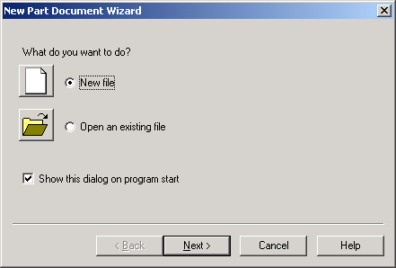
New Part Document Wizard
When you Start FeatureCAM the New Part Document Wizard is the first thing you see. Click Open an existing file to work on an old FeatureCAM file. Click on New File to begin a new part. Click Next and follow the instructions in the next two sections.

New File
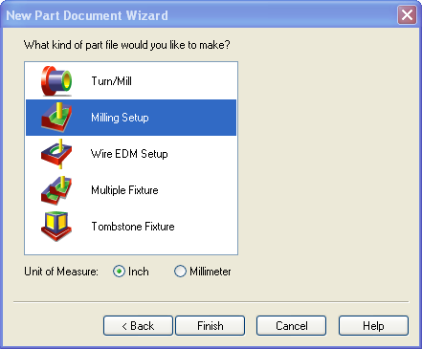
When you click New file in the New Part Document Wizard, the choices that you are offered will be limited by the FeatureCAM modules you have purchased. Initially you are offered the choices of a Turning or Milling or Turn/Mill Setup, Wire EDM Setup, Multiple or Tombstone Fixture, and a Unit of Measurement choice.
In this course, we will only explore the Milling Setup.

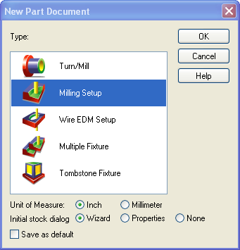
You can also click the New  button start a New Part after pressing Cancel in the New Part Document Wizard. You will also find this button on the Standard Toolbar once you are in the main FeatureCAM interface. This button can start a new part at any time without the need to close the current part.
The New Part Document dialog box has the same selections as the New Part Document Wizard with the addition of being able to select your Initial stock dialog options.

Once you have selected the type of part document you are going to create and the unit of measure, click the Finish button to proceed with defining your stock. We will go over defining the stock later in the course.

Chapter 2 – Introduction to Solid Modeling
Chapter
2
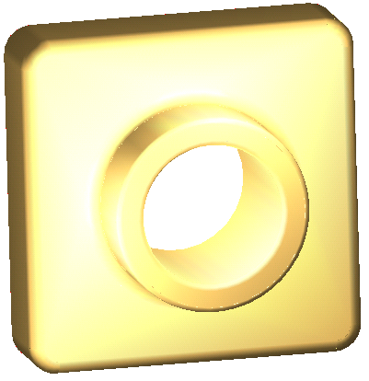
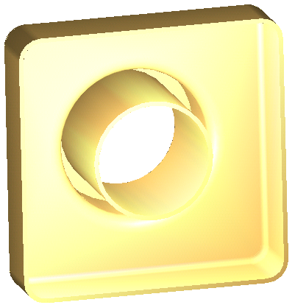
This chapter guides you through the creation of a basic three dimensional part using the solid modeling capabilities that are built into FeatureCAM. You will create this simple part:

This chapter includes:
- Creating a base solid from stock
- Adding material with an extrude
- Cutting material with an extrude
- Modifying the solid with fillets
- Shelling the solid

Class Follow-Along

Creating a New Part
- 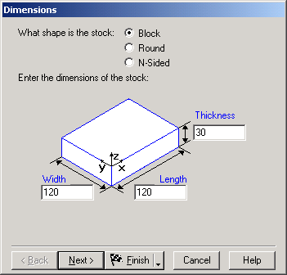Open a New Part document
- From the New Part Document Wizard, select a Milling Setup with Millimeter as your Unit of Measurement, click .
- Choose a Block Stock and set the Width to 120, the Length to 120 and the Thickness to 30 then click .
4. The stock properties dialog box may pop up. You may use this to review the properties of the stock. Then click .

Creating a Base Solid
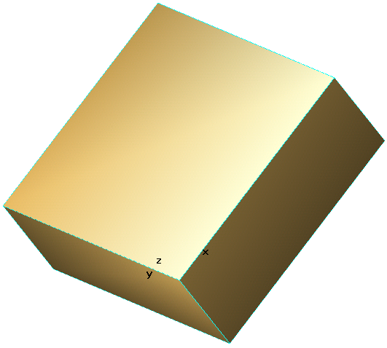We want to create a Solid, so pick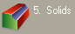 from the Steps Toolbox to the left of the Graphics Window
- Select Use the Stock as the Base Solid and click .
- Name your Solid “Widget”, verify that Stock is selected and click .
The Stock choice will link the stock and the base solid parametrically. The Cube choice will create a cube with set dimensions.
You have now created a base solid.
- View this solid by selecting the Shade button from the Standard Toolbar and rotate your solid.
Next, we need to add some material to our block shape.

Adding Material with Extrude
- Select Top view from the View menu and select  from the Steps Toolbox.
- Pick Circle from Rad, Center and draw a circle, Radius 35, located at 60,60,0.
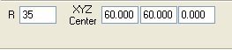.
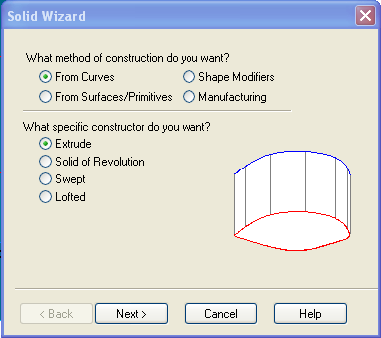
- Again, we are dealing with a solid so pick from the Steps Toolbox.

- We want to use the circle we just created to add material so select From Curves as the method of construction and Extrude as the specific constructor.

- Select As Add to add material to the base solid and select the circle we just created as the curve. The direction of the add will be a positive 30 in the Z direction. Select and .
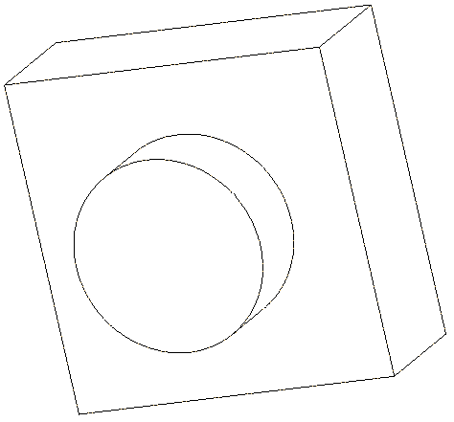Let’s view our new solid in Hidden line mode.
- First, select the Hide All option in the Advanced Toolbar
- Next, select the Show Solids 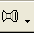 option from the Advanced Toolbar
- Now select under Display Modes in the View menu and rotate the part for a better view.

Cutting Material with Extrude
- 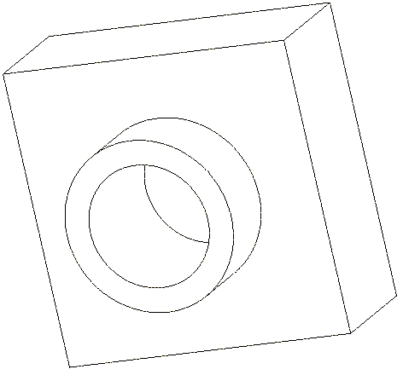Return to the Top View and select from the Steps Toolbox.
- Draw a circle, Radius 25 at 60,60,30
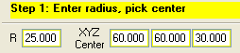
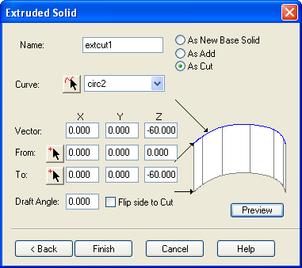
- Pick from the Steps Toolbox.
- We want to use the circle we just created to cut material so select From Curves as the method of construction and Extrude as the specific constructor.
- Select As Cut to cut material from the solid and select the circle we just created as the curve. The direction of the cut will be a negative 60 in the Z direction.

We have finished the basic shape of our part. Now we will finish off the part by adding some fillets and finally shelling the part.

Adding Fillets
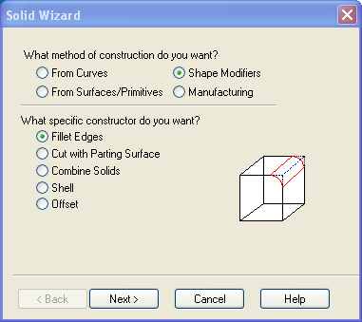
- To fillet a solid, first select from the Steps Toolbox.
- We want to modify the shape of the four external edges of the original square solid so select Shape Modifiers as the method of construction and Fillet Edges as the specific constructor and click .

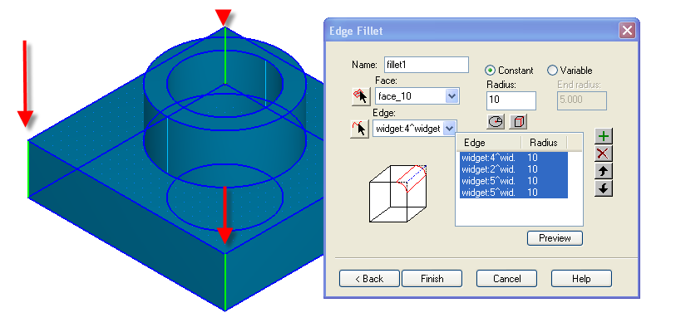
- Round off the square edges with a 10mm fillet by setting the Radius to 10 and selecting each of the four edges individually from the Graphics window.

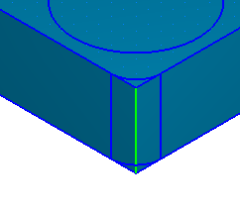
- Preview the result of the edges you picked by clicking on the button.

- Click if the results are what you expected.

- Round off the top corners of the square section and the base of the round extrude with 5mm fillets using the same solid filleting procedure that we just used.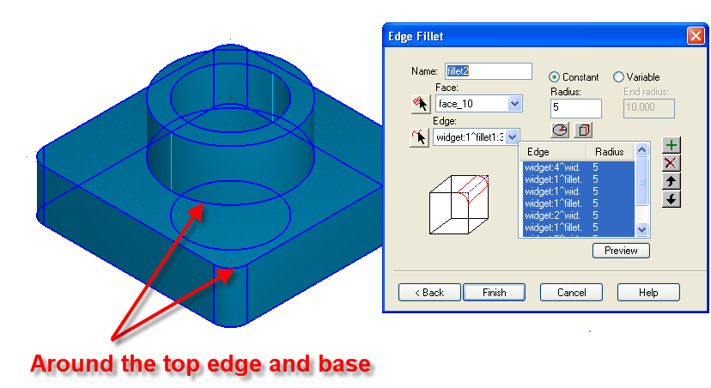
- Finish the filleting by putting a 2mm fillet around the top circular edges.

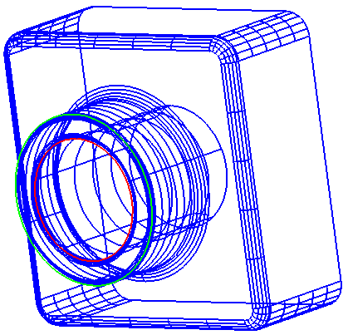

Shelling the Part
We will finish the design of our part by shelling it.
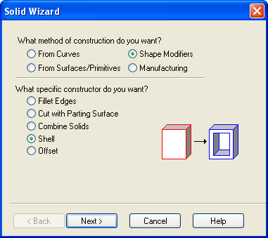
- Select from the Steps Toolbox.
- Under the Shape Modifiers is a Shell command. Select it and click .
To shell a solid, you must select the width of the shell by selecting an offset distance.

- For our part, set the offset distance to –2.00 and select the back surface as a face to not offset. Note, you may have to rotate the part to accurately select the back face.
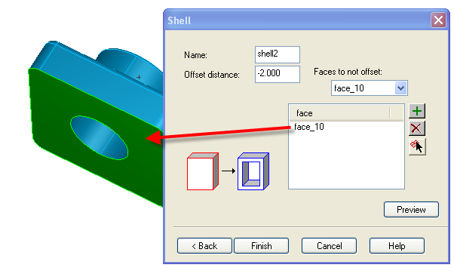

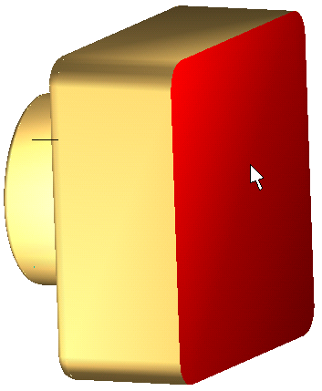
- the part and click .

- Shade the part and rotate it to see the finished part.
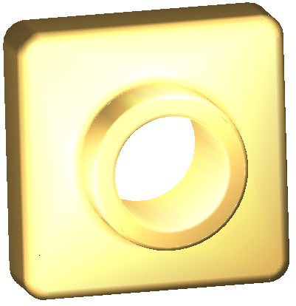

Chapter 3 – Modeling
Chapter
3
This chapter will explore the modeling methods used in FeatureCAM. With this knowledge you will be able to construct three-dimensional parts from scratch or modify solids that are imported from other solid modeling programs.

Creating Solids
The first option for three-dimensional modeling within FeatureCAM is to create a solid.

Solids Wizard

The first step to creating a solid is to use the Solids Wizard.
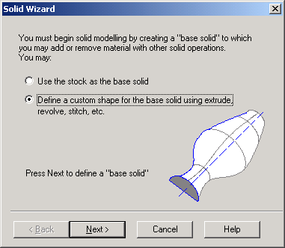
Click on in the Steps Toolbox to the left of the Graphics window to bring up the Solids Wizard.
FeatureCAM will recognize if there is not a solid in the current part file and bring up a dialog box that helps you to create a base solid. Your choices are:
- Use the stock as a base solid. If this option is chosen, a dialog box is presented for you to create the base solid from the stock or make another cube shape.
- Design a custom shape. With this option selected, the normal Solid Wizard is presented.
You can also bring up the Solid Wizard by clicking the Solid Wizard button in the Advanced toolbar.
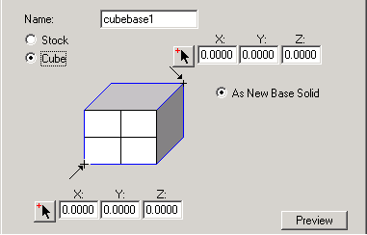
Follow these steps to use the Solid Wizard.
The Solid Cube dialog box creates a base feature from the stock dimensions or allows you to create a cube design feature
Select from the Steps Toolbox or click to bring up the Solid Wizard.
Select a method of solid construction.
Select a specific solid constructor.
Click to bring up the dialog box for the specific solid constructor.

Solids from Curves
Extrude  - Extrude creates a solid design feature by pushing a curve in a straight line.  - Curve needs to be closed.  - Direction and length of extrude is determined by a vector or two points  - Direction is relative to the current UCS | 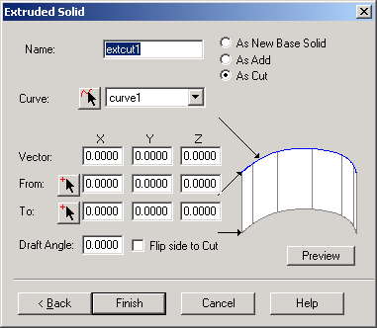
Revolution  - Solid of revolution creates a solid design feature by revolving a Curve around a line or Axis.  - Revolve around X, Y, Z-Axis or a custom line.  - If the curve is not closed, you will be given the option to: Join the ends of the curve, Join the ends to the axis, or leave the curve open and Create a Non-Solid Result.  - Give a Start and End Angle between 0 and 360. | 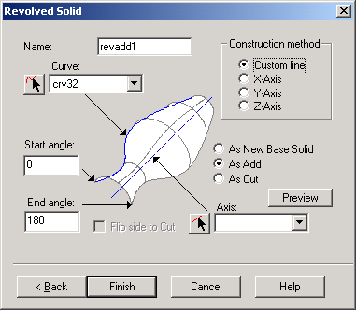
Swept  - A swept solid takes a curve, the Cross section, and runs it along another curve, the Axis.  - Click the button to check out your shape.  - If the sweep does not follow the Axis curve, click Sweep from other end and Preview again.  - If the cut is on the wrong side of the curve, click Flip side to cut and click Preview again to verify. | 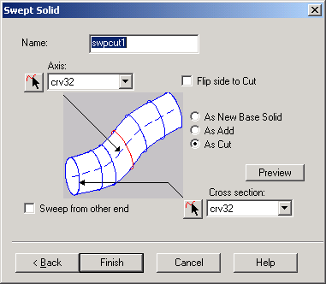
Lofted  - Lofting takes a series of two or more closed Curves and fits a solid between them.  - A Closed loft with extend the solid from the last curve picked to the first curve picked.  - Lofting curves that are not closed will result in non-solid results.  - If the loft twists unexpectedly, try reversing the curve. | 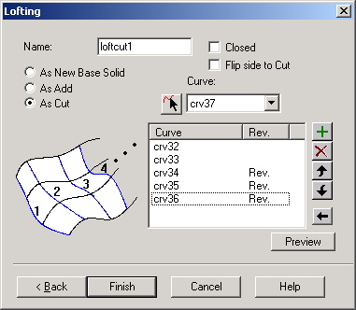

Shape Modifiers
Fillet Edges  - To fillet a solid, you must simply select the edges of the solid and enter fillet radii.  - Variable radius fillets can be achieved by selecting variable and specifying a starting radius and an ending radius.  - Individual edges can have their own radius. Click the button to set the radius on a selected edge.  - Select the button to apply the same radius to all edges.  - If multiple filleting operations are used, a general rule of thumb is to do the larger fillets first and the smaller fillets last. | 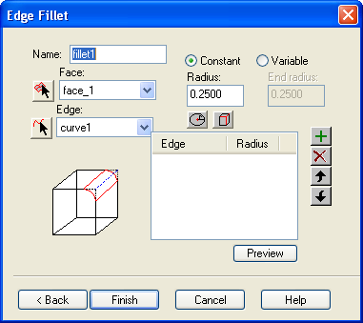
Cut with Parting Surface  - Cut a solid with a surface or a collection of surfaces with common edges.  - Useful for separating the solid into two mold halves.  - If you wish to create a solid for both sides, check the Keep both sides checkbox.  - Click Preview to verify the side that will be kept. If you want to cut on the other side of the surface(s), select the surface name and click . | 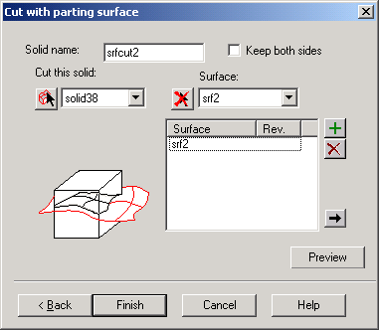
Combine Solids  - Combine solids allows you to take two different solids and combine them into a single solid.  - Difference operation subtracts from Solid1 the portion of Solid2 that is inside Solid1.  - Union operation adds to Solid1 the portion of Solid2 that is outside Solid1.  - Intersection operation results in the volume that is common to both Solid1 and Solid2. | 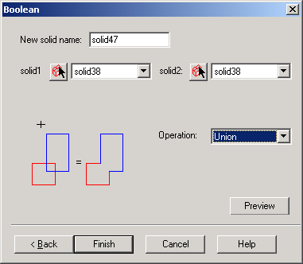
Shell  - The shell operation will create a thin-walled solid from the selected solid.  - Offset distance controls the wall thickness of the shell. A positive number shells to the outside of the solid while a negative number (most common) shell to the inside of the solid.  - If you want to exclude any faces, select the name of the face(s) as Faces to not offset. | 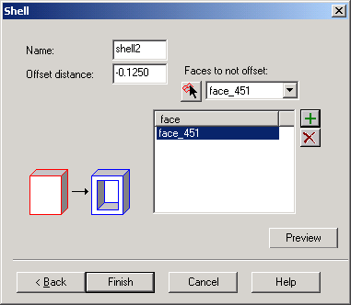
Offset  - The offset operation will create an offset solid from an original.  - Offset distance controls the distance from the original solid. A positive number offsets to the outside of the solid while a negative number offsets to the inside of the solid. | 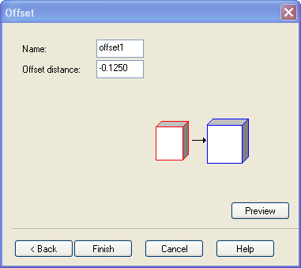

Solids from Surfaces/Primitives
Stitch  - Stitching converts well-trimmed surface models with shared edges and shared boundaries into solid models.  - Surfaces must not overlap of have gaps between them or they will not stitch.  - Great for converting well trimmed IGES files or FeatureCAM surfaces to solids  - If the surfaces form a sheet instead of a solid, click the Non-solid results OK checkbox.  - Make sure that no duplicate surfaces are displayed.  - Trim any overlapping surfaces before stitching. | 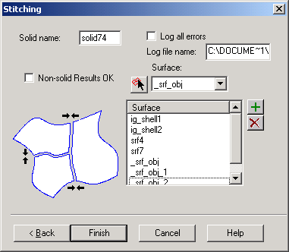
From 2.5D Feature  - Will subtract the shape of the 2.5D feature from a solid.  - Side features cannot be converted to a solid.  - If you have more than one base solid created, select the name of the solid to apply the 2.5D feature to.  - All features are subtracted from the solid, even bosses. | 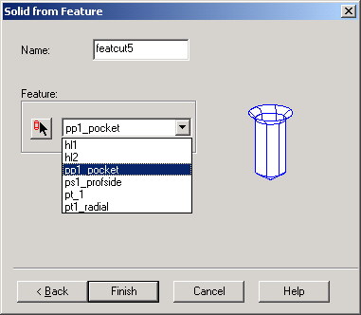
From Stock (Cube)  - Creates a base feature from the stock dimensions or allows you to create a cube design feature. | 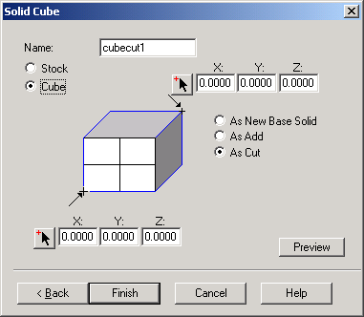

Extrude a Surface  - Creates a solid from a surface.  - Surface can be extruded in different directions | 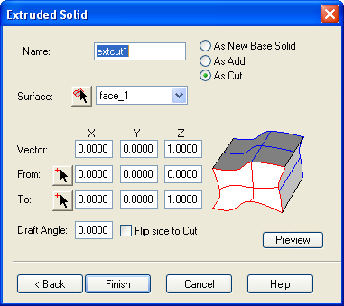
Revolve a Surface  - Creates a solid from a surface.  - Solid takes a surface, the cross sectional area, and runs it along a curve, the Axis. | 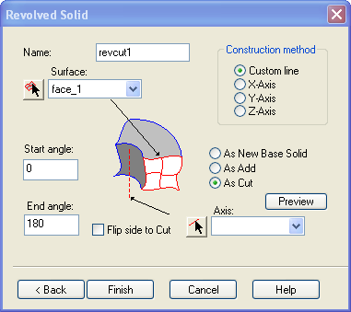

Manufacturing
Silhouette Curve  - Will generate a curve to represent the widest part of a solid.  - Useful for parting curves for molds.  - These curves can also be used to split the faces of a solid.  - Curve created at the widest extent of a part when viewed form the +Z direction.  - Works well with Select Core/Cavity. | 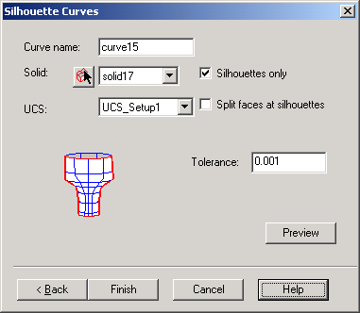
Select Core/Cavity  - From a top view in the selected UCS, this operation uses surface orientation to select surfaces from a solid that are either pointing towards you or away from you.  - Surfaces pointing toward you are classified as core.  - Surfaces pointing away are classified as cavity.  - If there are surfaces you would like to exclude, select them in the Don’t include faces area.  - Include Vertical Surfaces will include the vertical surfaces that are next to the core/cavity surfaces. | 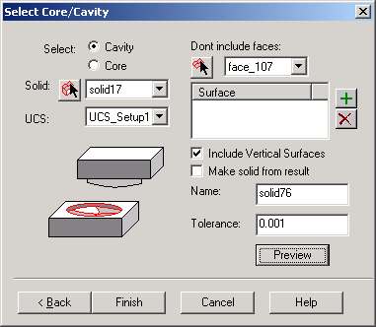
Split Face  - Use this operation to select a face and split it into multiple faces.  - Projects a curve or list of curves on to a face.  - Uses the projected curves as the boundaries. | 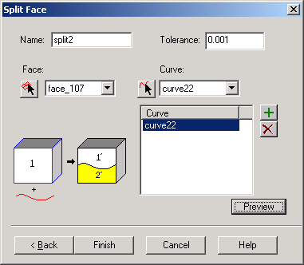

Delete Face  - Use this operation to select a face and remove it from a model  - Useful when deleting holes.  - Use the “heal remaining faces” so the material is filled back in that region. | 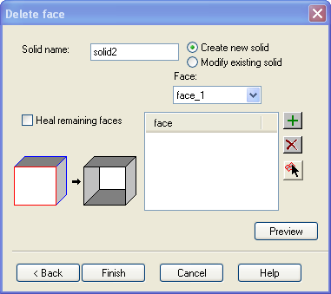
Explode Face  - Use this operation to select a solid and split it into multiple surfaces.  - Use it to model surfaces.  - Use it to create surface models. | 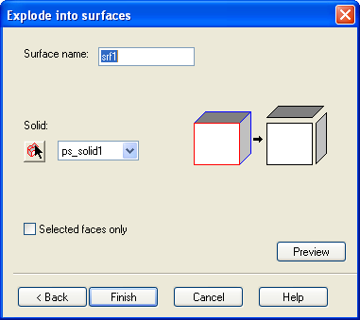
Parting Surface  - Uses a curve and creates a parting surface.  - Specify the Land width. This is the width of your parting surface.  - Specify the UCS you would like to use. The Z axis of this UCS will be used as the parting direction.  - Use the to view your projected curve as the surface. | 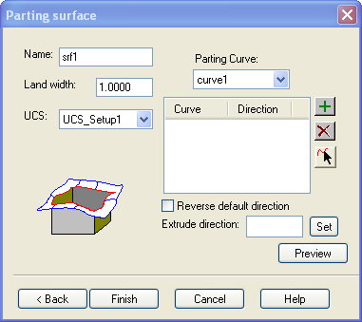
Draft a face  - Set a draft angle on one or more faces individually.  - Enter the draft angle in degrees.  - Select the fixed reference surface by clicking the pick surface button and picking a surface. This is the surface the draft will start from.  - Use the to view your draft. | 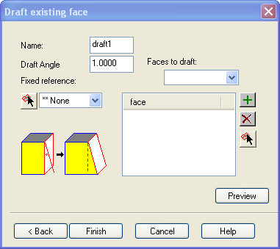

Creating Basic Surfaces

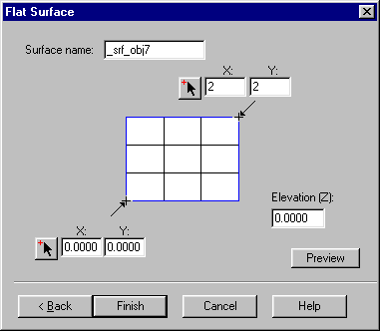
Flat
- Use primitive surface in the surface wizard.
- Creates a flat surface from two points.
- Can specify Z coordinate from “elevation” parameter.
- Useful for slicing a part model.

Chapter 4 – Modeling Exercise
Chapter
4
This chapter will guide you through modeling a blow dryer using the solid modeling techniques that you have learned about in the previous chapters. You will learn to use multiple base solids, draft angles, filleting and more. Finally, you will cut the solid in preparation for manufacturing.

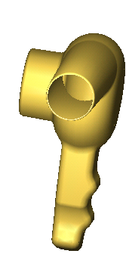
Hair Dryer
t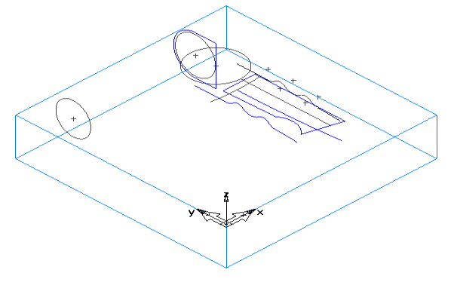o begin, we need a Base Solid. A base solid defines the initial shape of the solid. We will then use solid constructors to add to or cut away portions resulting in a model of our part.
Open “Solid dryer curves.fm”
This file contains geometry and curves needed to create the dryer.

Before We Start
Do you understand how the geometry was created?
Do you understand how the curves were created?

Handle
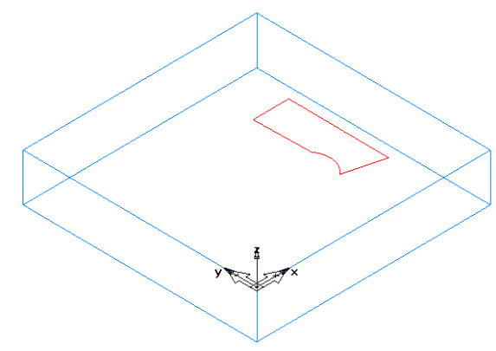Let’s create the handle portion of the dryer first. We will use the curve that describes the outside shape of the handle, and extrude it (with a draft angle). Extrude creates a solid design feature by pushing a curve in a straight line (vector).
Because this is the first “solid” we are creating, it must be a created as a New Base Solid.
☞
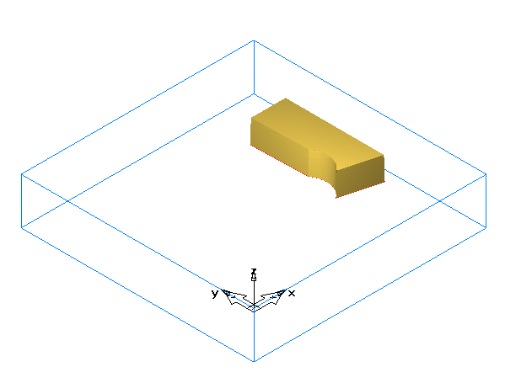
Extrude Curve3 as a New Base Solid. Extrude +1 inch Z direction. Apply a 1 degree taper to the walls of the extrude. Notice taper direction (-1 degree taper)

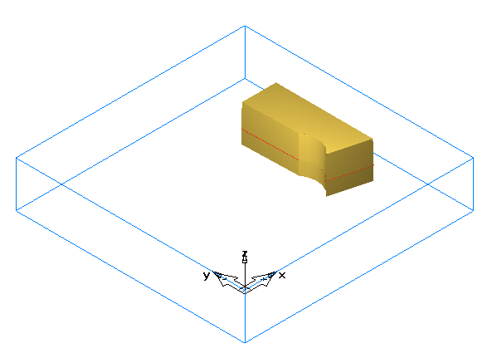

Extrude Curve3 as an Extrude, As Add. Extrude 0.6 inch in -Z direction. Apply a 1-degree taper to the walls. Notice taper direction.
Cut the finger bumps in the handle next. Extrude
Crv30 as an Extrude, As Cut. Extrude +3 inches in X, . Notice the arrows in the blue preview display. The arrow indicates which side of the curve the solid will keep. Toggle “Flip side to cut” and Preview to change and view which side is kept.
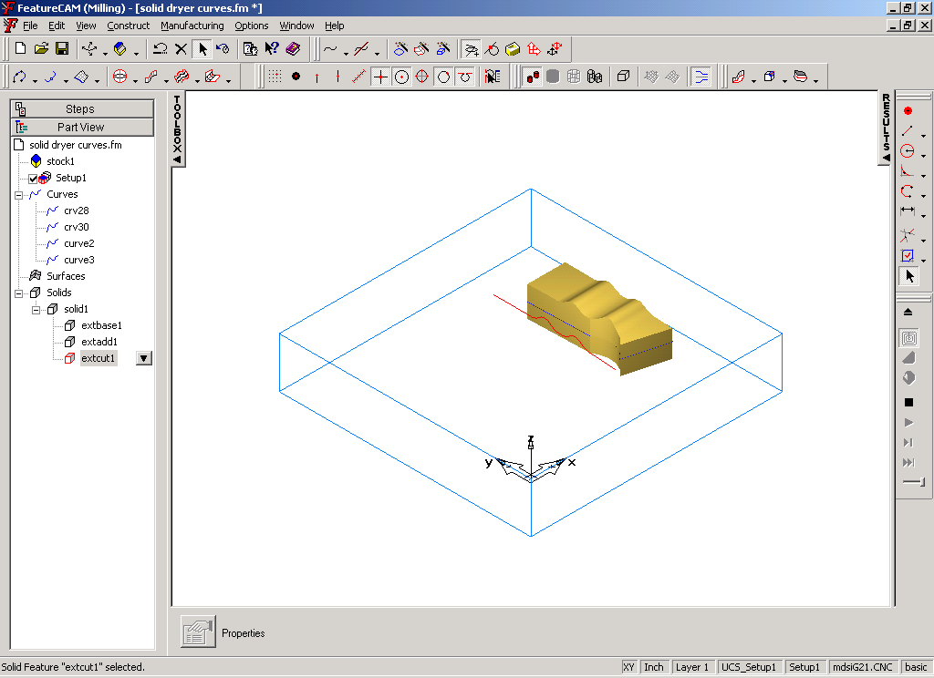
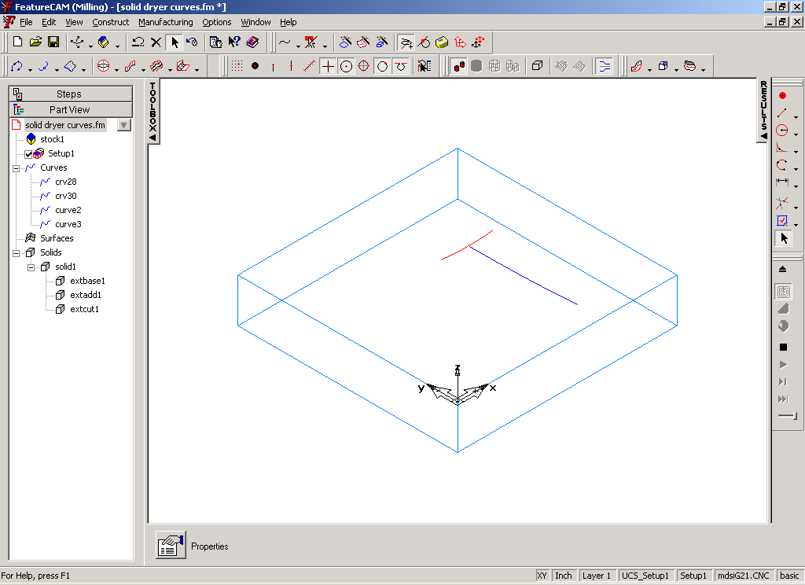

Next cut the curved palm section on the bottom side of the handle. Use the Swept Solid constructor to Sweep, As Cut. A swept solid constructor takes a curve and runs it along another curve. Use Circ28 as the cross section and Crv28 as the axis. The figures below show the result. Note that the surface is curved in two directions.
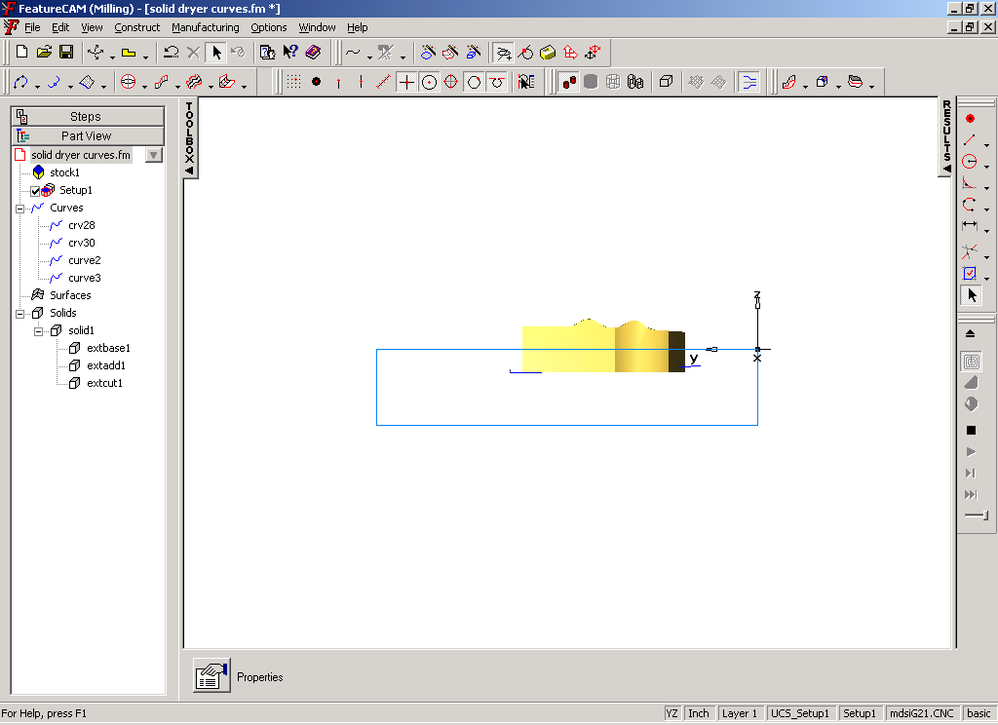
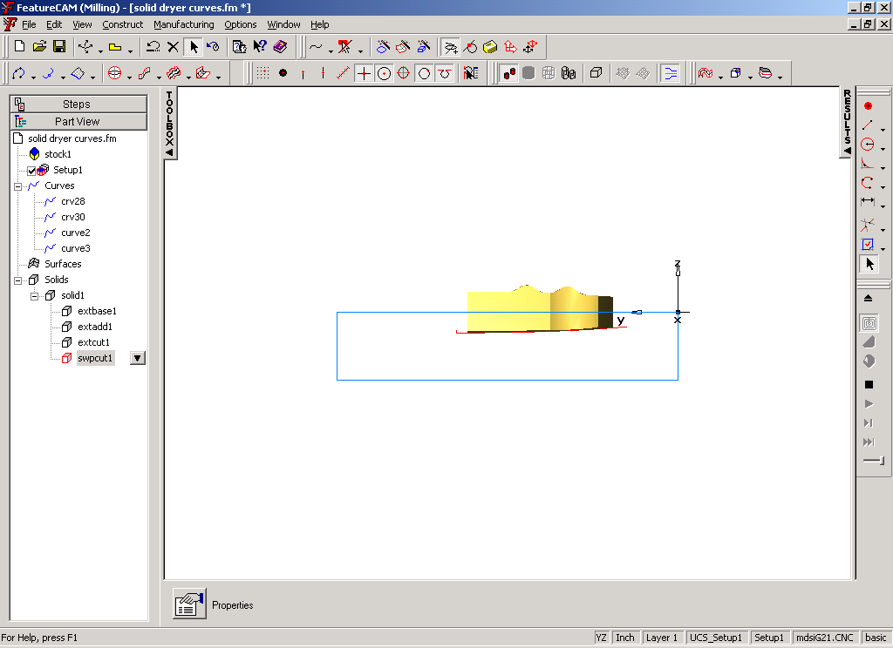

Fan Area
Now create the fan area. Create as a New Base Solid. We are not required to create a new base solid. We are doing this to illustrate that you can have more than one solid in FeatureCAM and to illustrate how we can combine two or more solids.
Do a Hide All Surfaces to hide the solid we created. Hide all surfaces will hide solids, faces, sheets and surfaces
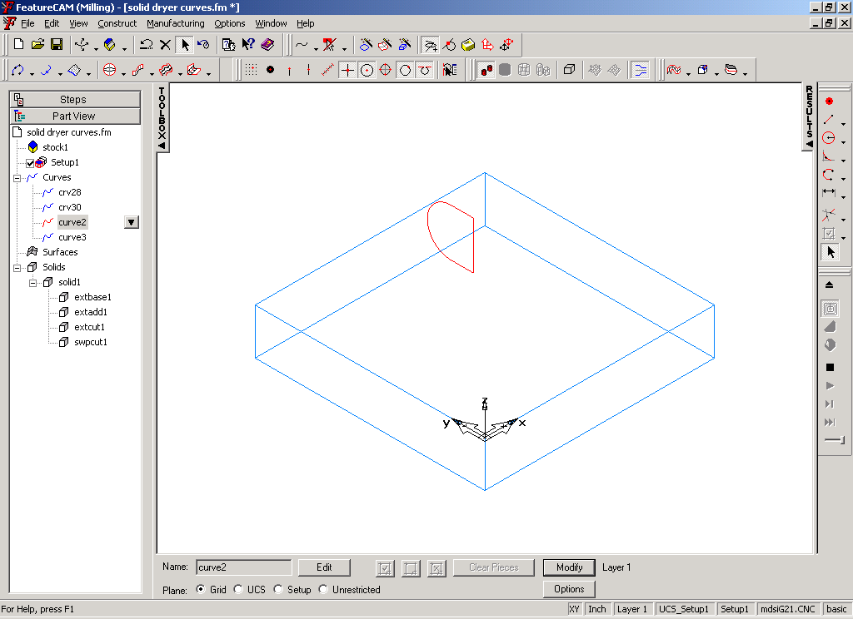
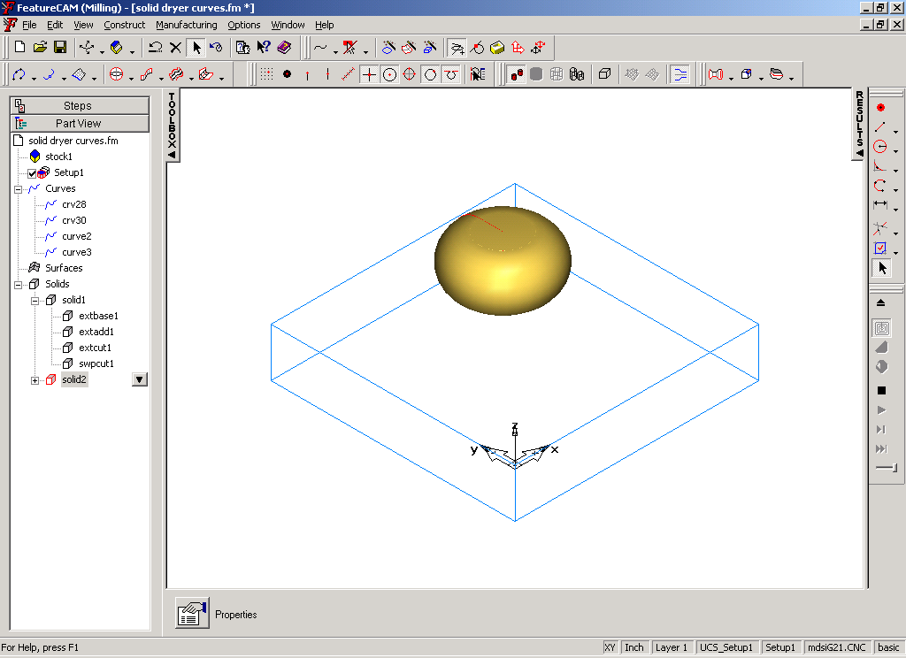
Use the Revolved Solid constructor to create a new solid for the round fan housing area. A solid of revolution creates a solid design feature by revolving a curve around a line. Use Curve2 as the curve and ln59 as the axis. Revolve 360 degrees; be sure to select As New Base Solid.
Now use the Loft Solid constructor to create the nozzle portion between the two circles shown (circ20 and circ61). This design feature takes a series of curves and creates a solid between them. Use Loft, As Add, to add to the new solid created by solid of revolution.
Be sure the solid being added to is the “fan area” solid.
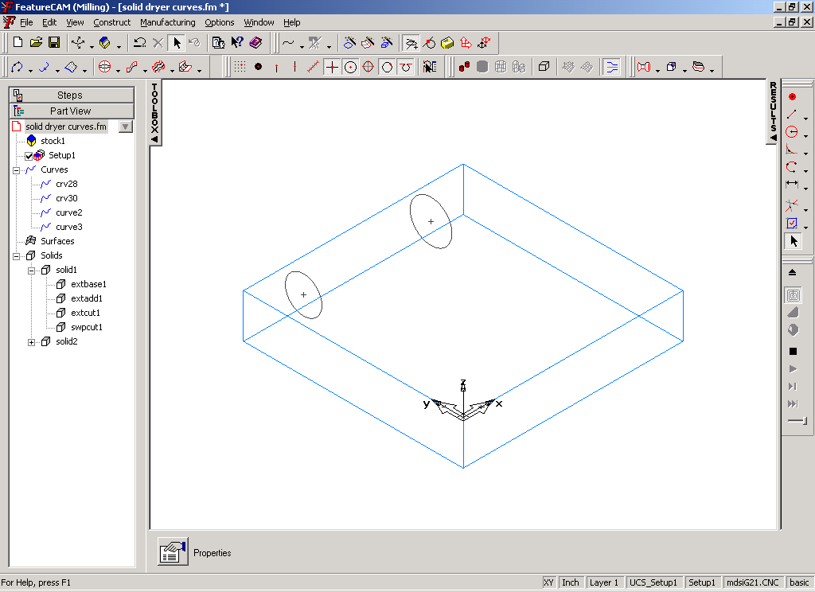
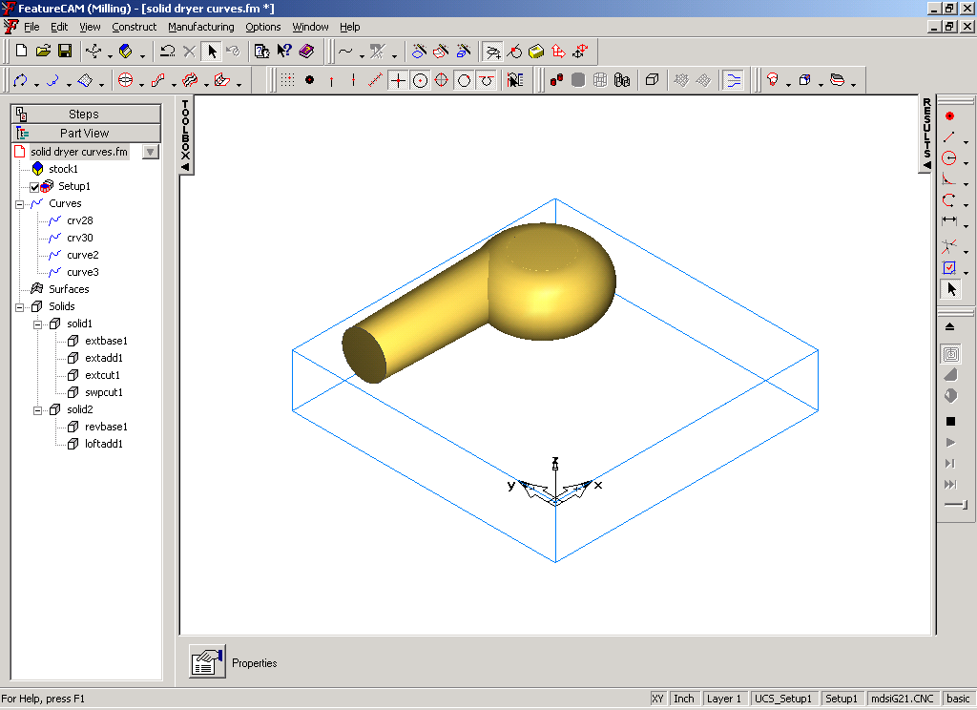
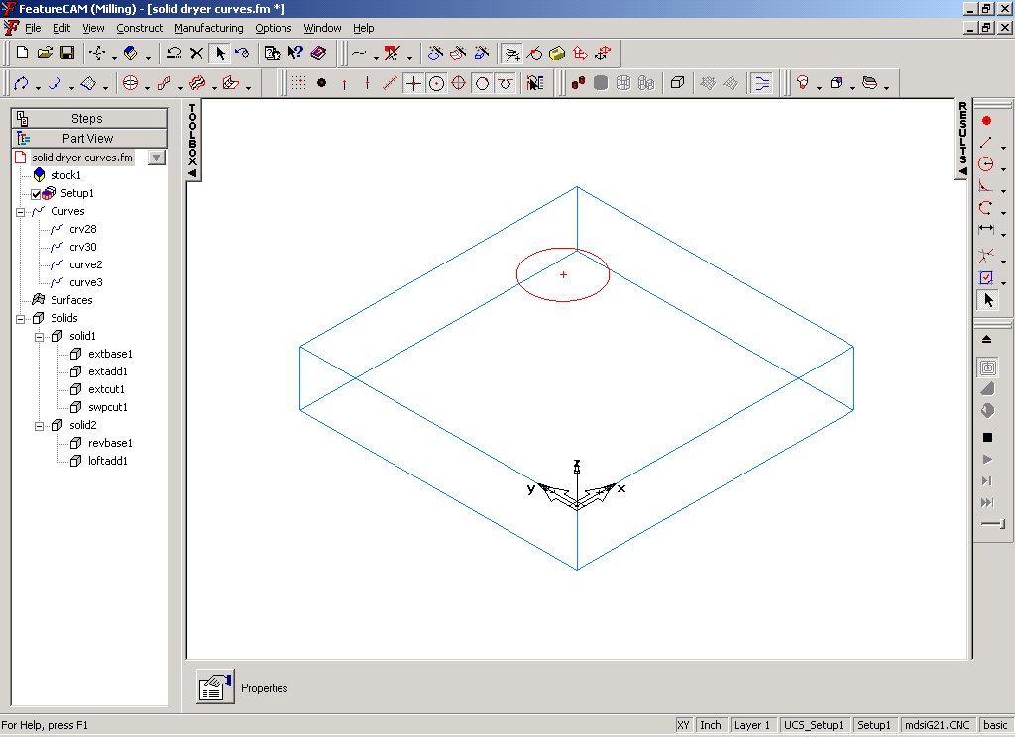
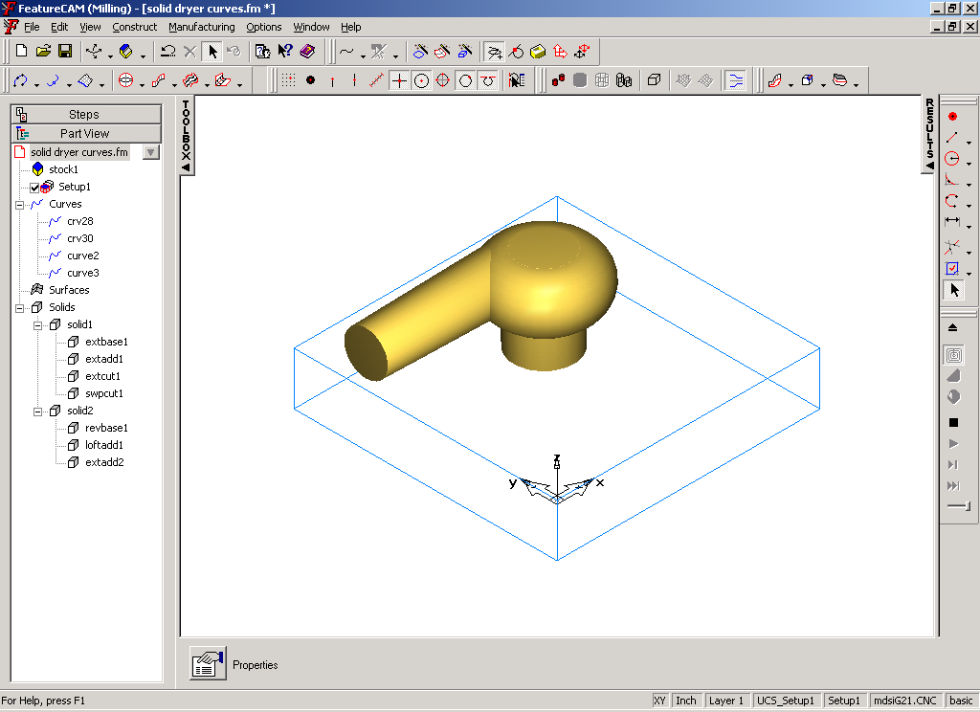
Use the Extrude solid constructor to create the motor housing. Use Extrude, As Add. Use circ14 as the curve and extrude in a –Z direction, 2.2 inches.

We have created a solid that makes up the handle and another solid that makes up the nozzle/fan/motor. Look in the part view and notice how they are denoted. Right mouse click on the handle solid in the Part View and Show Selected. You should see both solids. Let’s combine these two solids into a single solid so we can fillet between the handle and the body. Use Combine solids to join these into a single solid. Select the handle solid as Solid1 and the body solid as solid2. Use the Union operation to get the combined total of both solids.
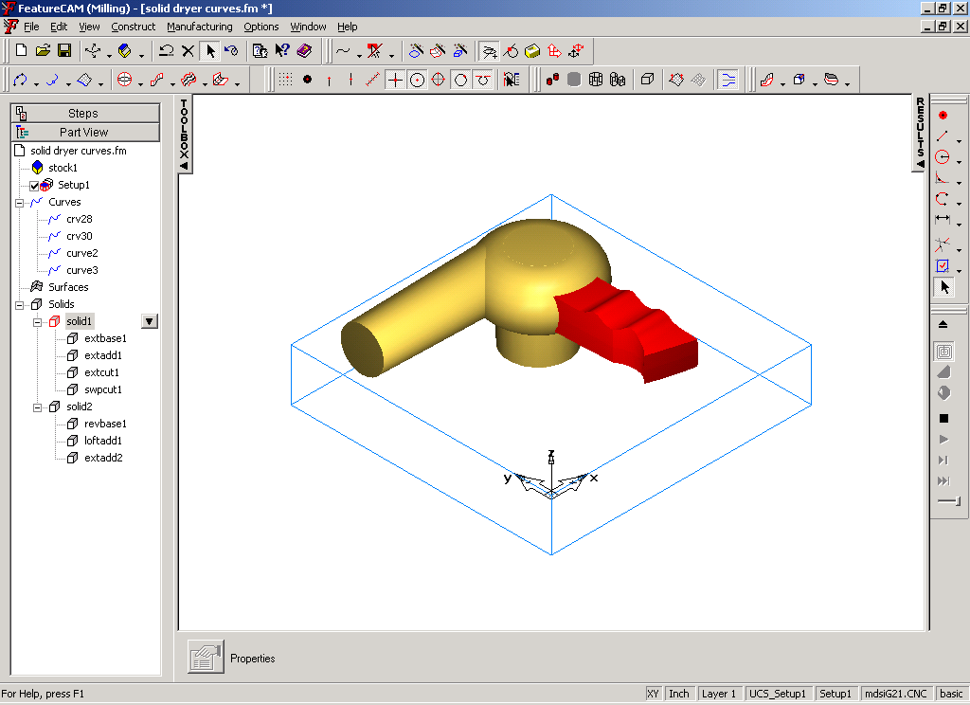
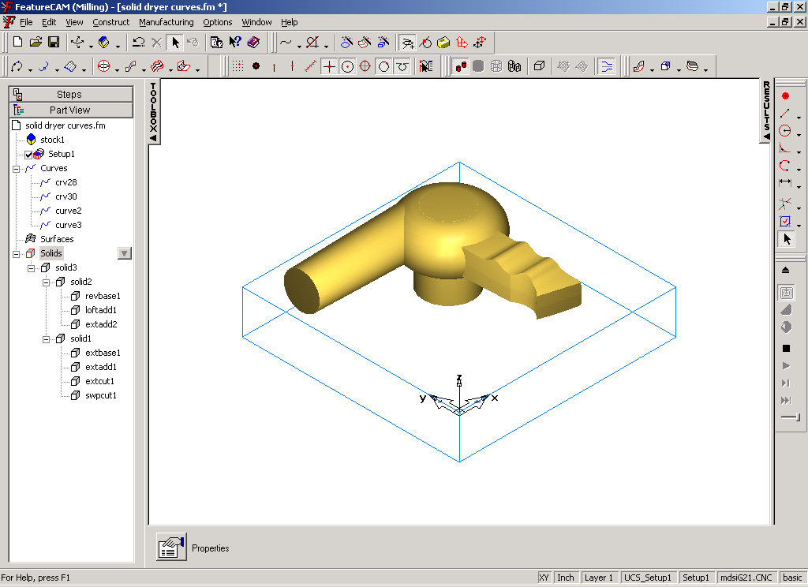

Filleting
Solid modeling gives you some powerful modeling tools, filleting is a good example. To create a fillet, we specify (pick) the edges we want round off. An edge is automatically created wherever two or more faces share a common boundary.

Set the fillet radius to 0.25 and pick all “outside” edges. As you pick an edge, it displays the selected edge (with an arrow). The previously selected edges are shown in the “highlight” color.
- You must select the mouse pick button to graphically pick the edges.
- The order the edges are pick does not matter
- You can pick faces by holding the shift key and picking the edge.

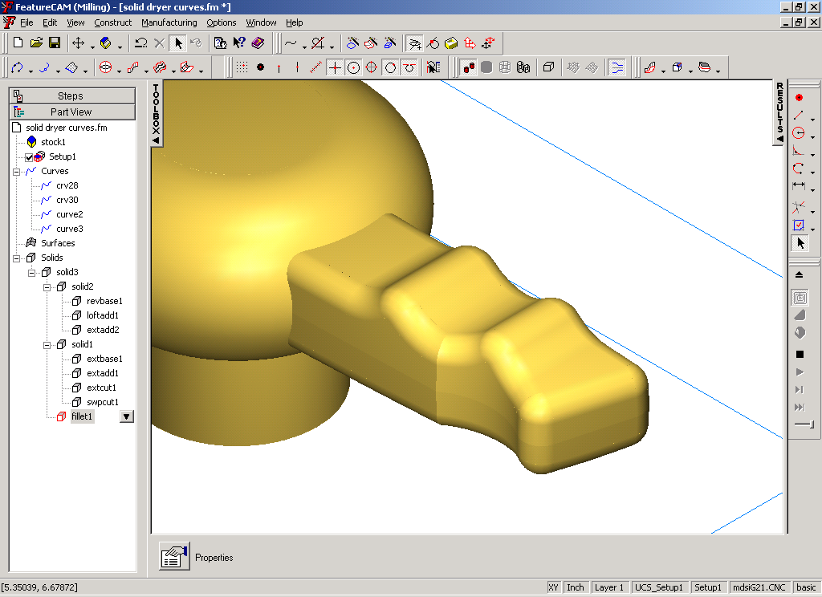
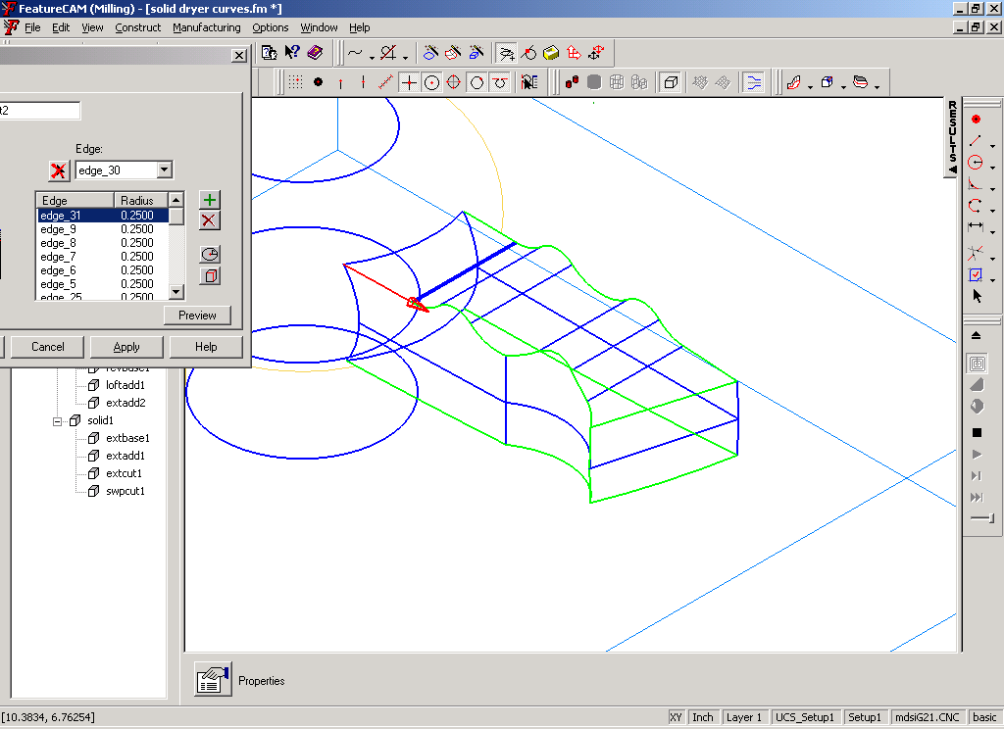
Create and shade.

Now fillet the handle to the body with a 0.375 radius. Create a new fillet (we could have added it to the previous fillet operation). Select the edges and create
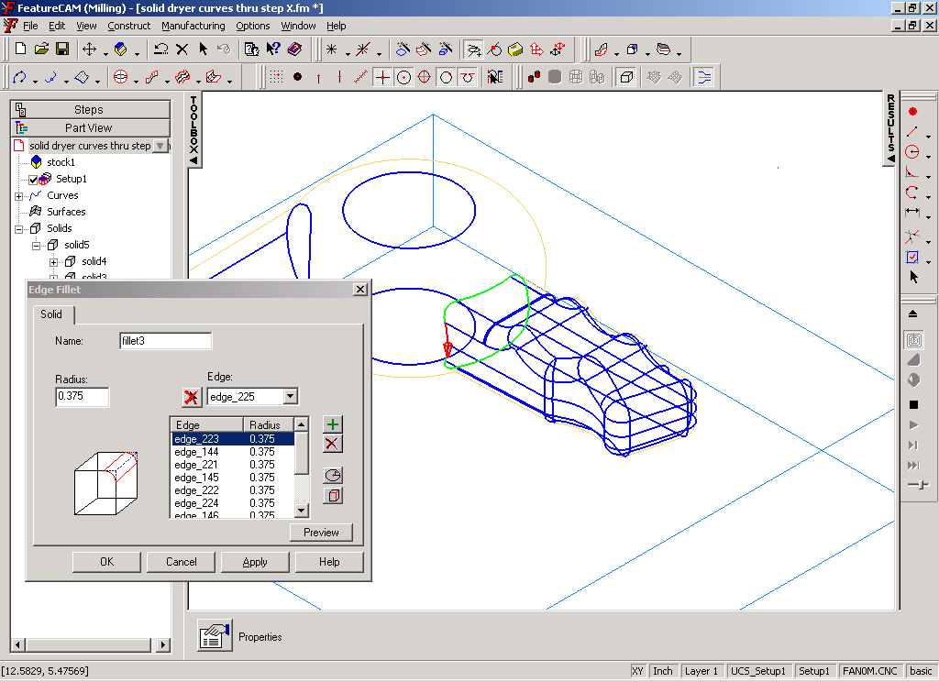
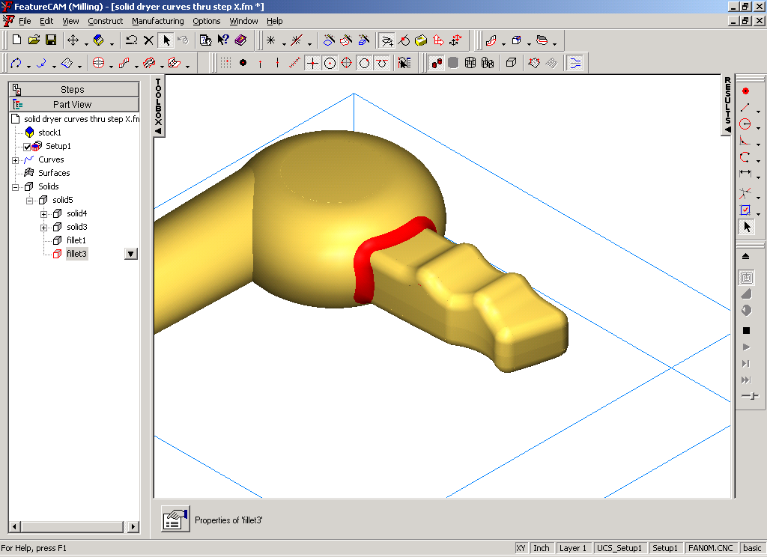
Create a fillet between the nozzle and the body. We are going to use a variable radius to blend these two regions together. Select one of the edges to fillet. Notice the edge is shown selected and that an arrowhead is displayed. The arrowhead indicates the end of the edge. When we specify a variable radius, we specify the start radius and end radius. The format is start radius, end radius (0.125,0.500). For our example enter .125,.5 in the Radius field. Click the “Set Radius on selected” button to set this radius on the selected edge.
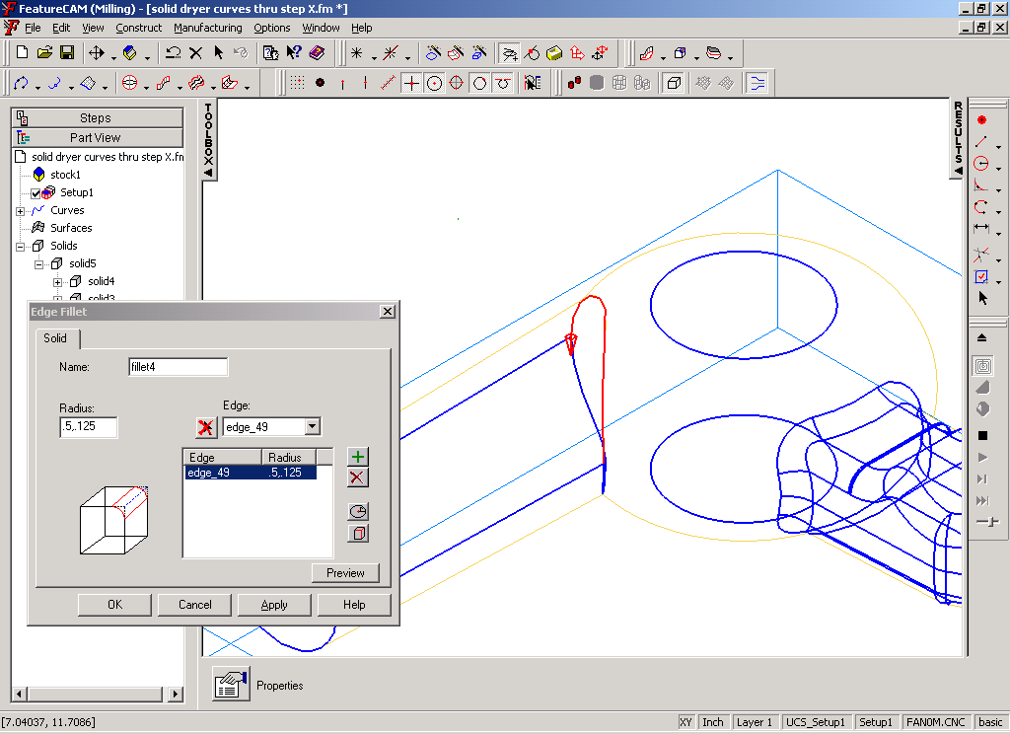
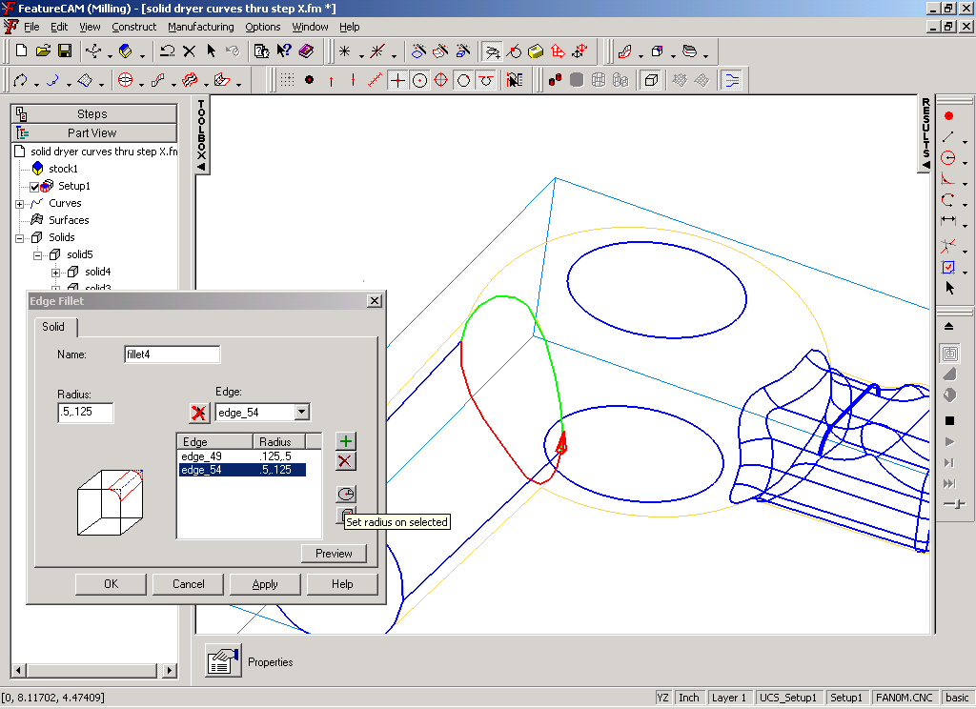
Pick the other edge to be filleted, set the fillet to .5,.125 (do you understand the direction?) and create the fillet. Shade, rotate and view .

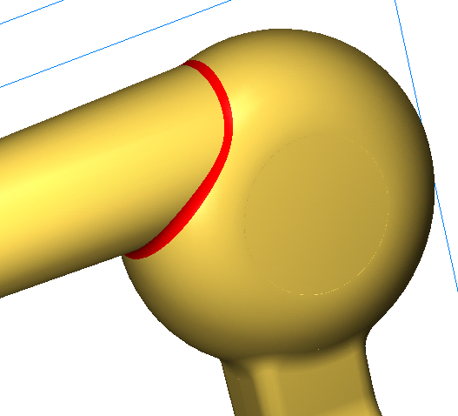
Fillet the end of the motor housing and the housing/fan junction with .125 fillets.
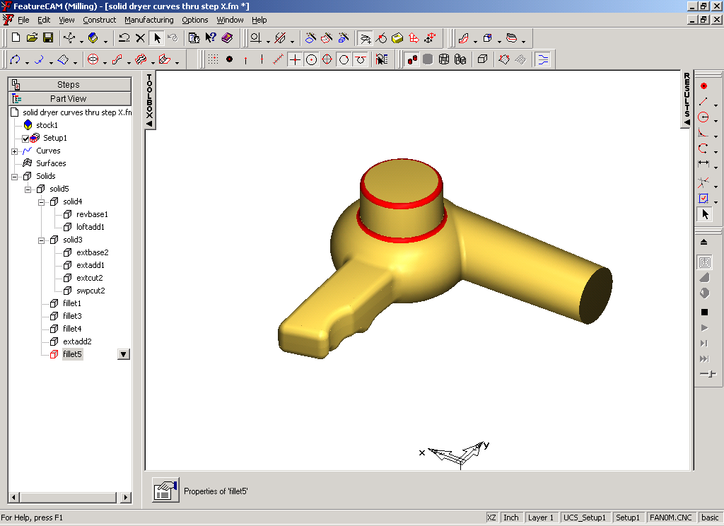
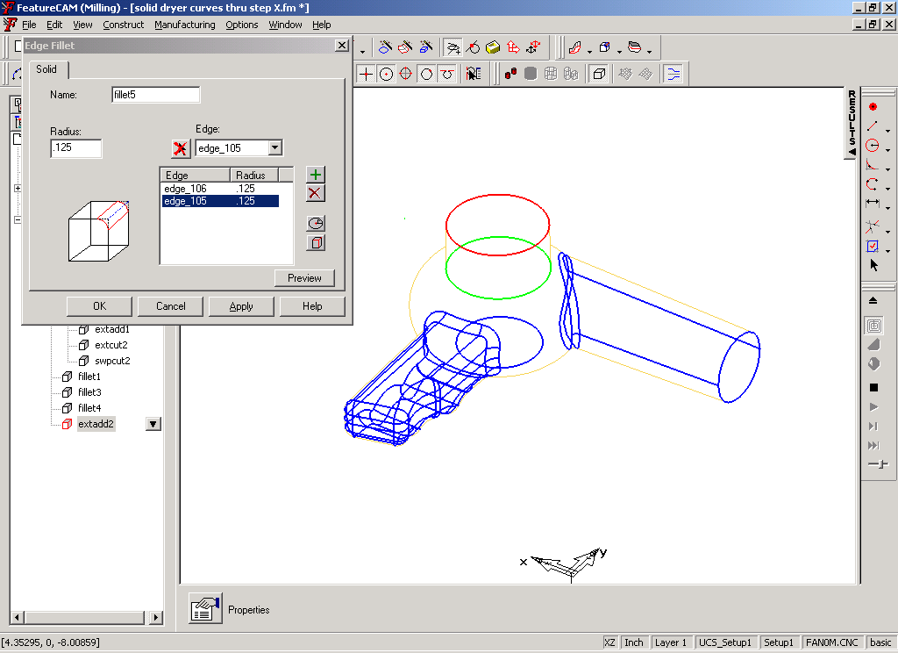
Set the radius to .125 and pick the 2 edges. Create and view.
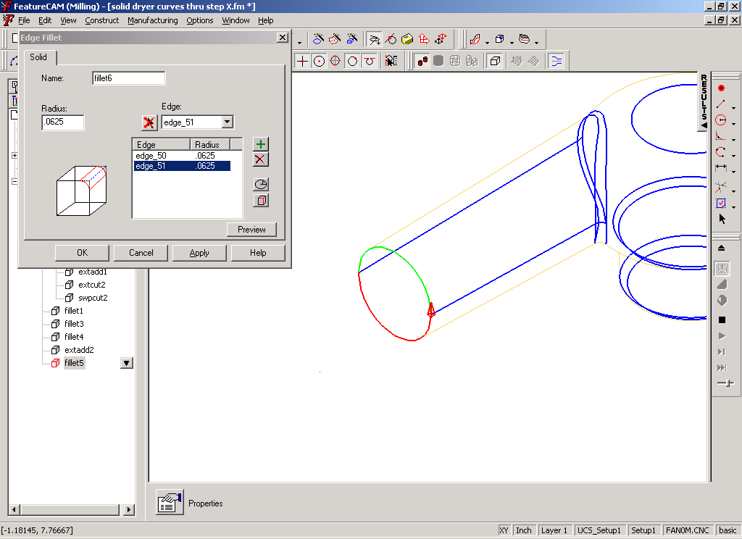
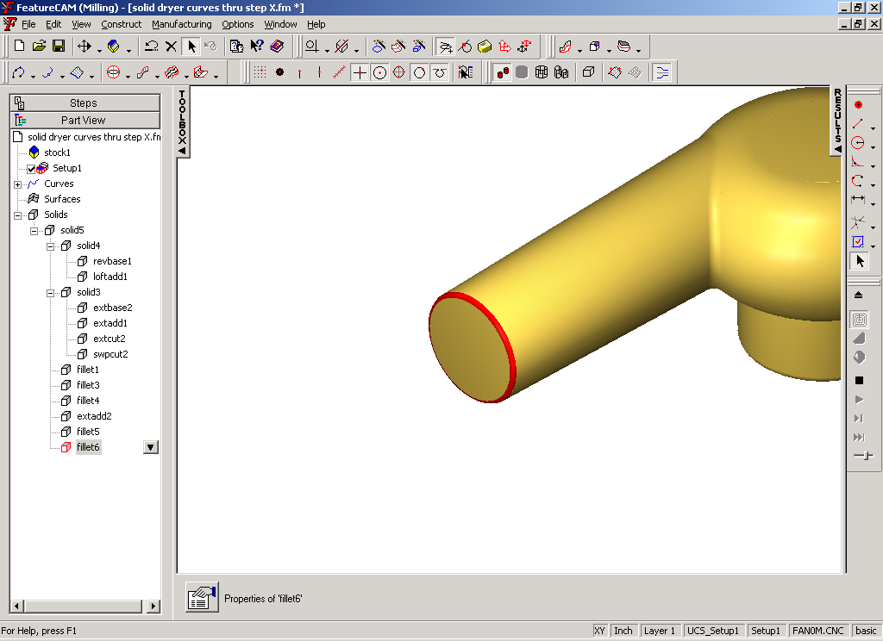
Lastly, fillet the end of the nozzle with 0.06 -inch radius. Enter .06 in radius field, select edges, and create.

Shell
Now “Shell” the model to hollow out the inside. Select the shell constructor. Set the offset amount to -.0625 (inward, .0625 wall thickness). Select the round end face of the nozzle as a “face to not offset”. This will leave an opening in the end of the nozzle. Create the shell. Rotate and view the model to see the results of the shell operation.
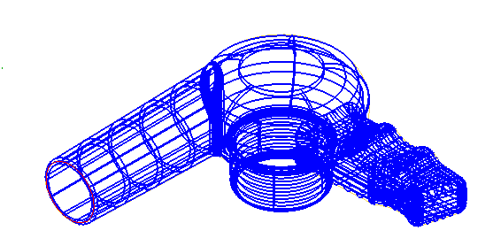
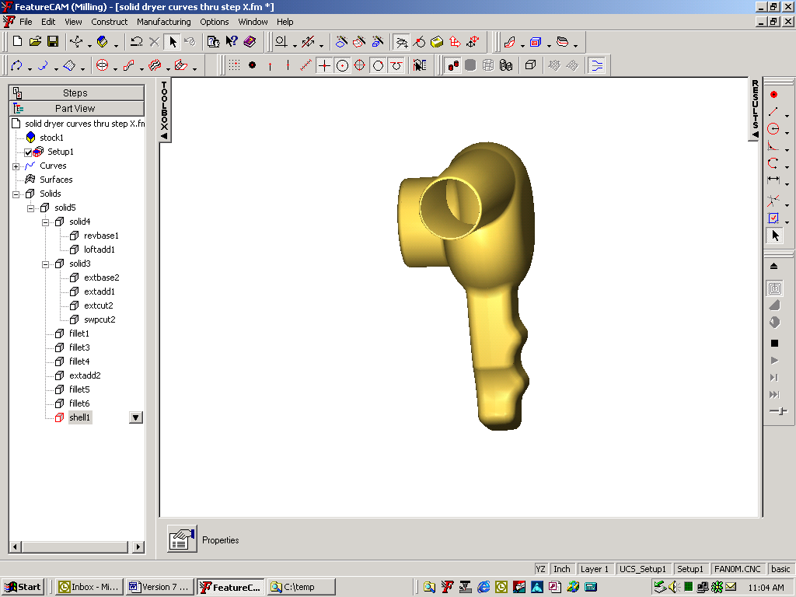
We have completed the creation of our solid model.

Core and Cavity Mold
Now lets deal with what it takes to make the core and cavity mold halves for one half of the dryer.
We have the model for the whole dryer. We need to cut it in half. We can use the “Cut with surface” constructor to cut our model in two. First we need a surface to cut with. A flat (plane) surface can be used as the cutting surface. Create a flat that extends beyond the extents of the model and at the Z location that cuts our model in half (Z=0)(Surface Wizard/Primitive Surface/Flat). Switch to the top view and create a flat surface.
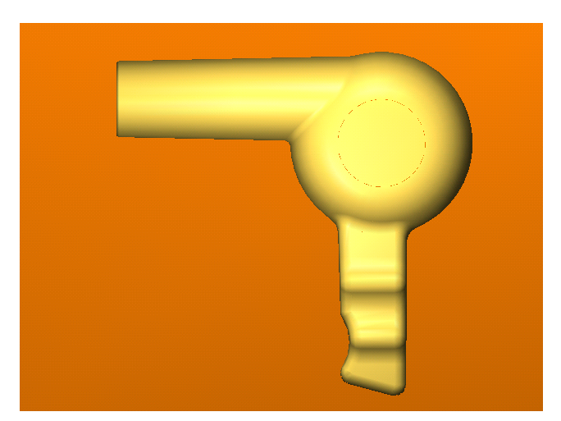

.

Use the “Cut with Surface” constructor to cut the model. Preview.
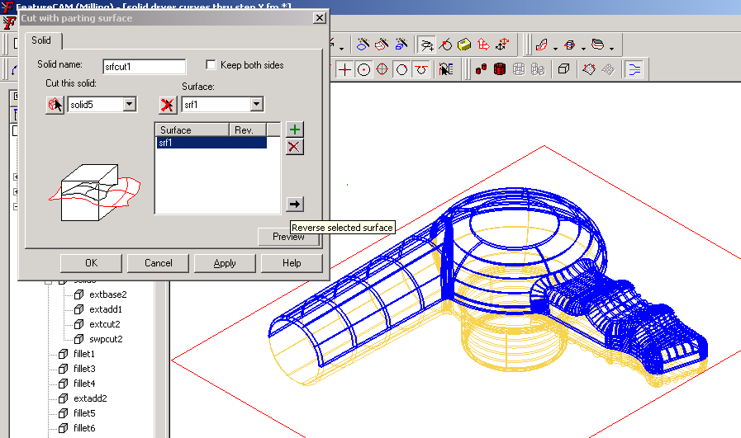

Preview shows (in blue) the portion it intends to keep. If the wrong side is shown, reverse the selected surface such that the bottom half is kept.

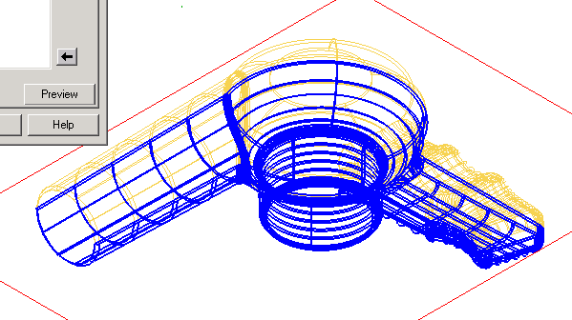
Create the solid, hide the surface used to cut the solid and view the part.
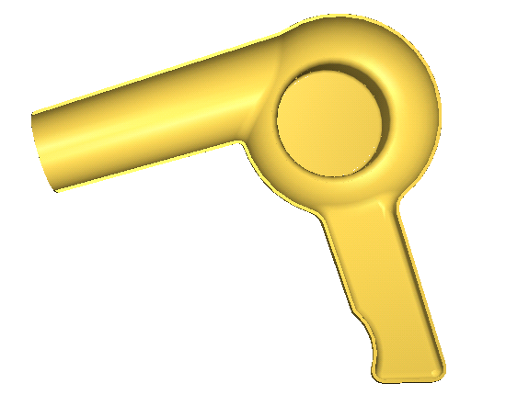

Making toolpaths.
Consider the case for making the cavity. We need to select the “outer skin ” faces (surfaces) to machine. We have a tool to help select the outer surfaces called Core/Cavity. Core/Cavity views the surfaces from the top view and then uses surface orientation to select surfaces that are either pointing towards you or away from you.
- All surfaces facing toward you are classified as core. Those facing away are cavity.

Use the Core/Cavity tool to automatically select the surfaces that make up the cavity.
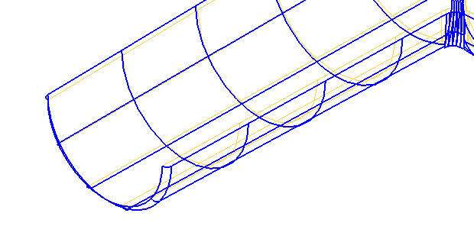
Because the surfaces that made up the cavity are “Facing away” from us, we should use the Cavity as the type; be sure the correct solid is selected to operate on and preview. Zoom in on the model. Notice “outer” or “facing away” surfaces have been selected. Click OK and notice which surfaces have been selected.

Go directly to the New Feature Wizard. Surface milling should be automatically selected. Why? Because the core/cavity tool selects only surfaces/faces.

Chapter 5 – Importing Files
Chapter
5
This chapter will discuss Importing files into FeatureCAM.
Importing Files

Import Option from File menu

- To import a file, you must open a document first.

- DWG, DXF AutoCAD files
- IGES Industry standard neutral CAD files
- GEO EZ-MILL, version 6 and earlier.
- SAT, SAB ACIS solid model format
- X_T, X_B Parasolid solid model format
- SLDPRT Solidworks
- PAR, ASM SolidEdge
- CATPART Catia V5
- PRT, ASM ProEngineer
- STEP, STP Step
- IPT, IAM Inventor
- MOD, MODEL Catia

Import/export options
- Always replace object on import affects all imports when checked and overwrites objects of the same name when you import. Unchecked has prompts for every replacement. You can’t have two objects with the same name in a FeatureMILL file.
- Smooth EZ-MILL curves affects .GEO imports and sets how to improve EZ-MILL curves on import as FeatureMILL has a higher resolution curve format.
- Keep IGES import log file affects IGES imports and sets whether to keep a log of the import process for later review or troubleshooting.
- IGES log file name affects IGES imports and sets the path and filename for saving a record of the import process.

- Physically dependent affects IGES imports and describes an IGES entity that can not exist by itself but is referenced by another entity. It can not exist unless the parent entity also exists. Turn off for Pro/Engineer import.
- Logically dependent affects IGES imports. Some IGES entities can exist by themselves, but are also referenced by another entity such as groups or grouping situations.
- Both physically and logically dependent affects IGES imports. Some IGES entities meet both logically and physically dependent criteria (referenced by at least two other entities and the parent for the logical link can not be the parent for the physical as well).
- Number of decimal places in IGES export determines how finely data is exported in the IGES format

Importing IGES files
IGES files contain entities of different types. The exact correlation between IGES and FeatureMILL is shown in the table below:
IGES Description | FM Object Type
Circular Arc | Circle and arc
Composite Curve | Curve
Conic Arc | Curve
Copious Data | Line
Plane | Part of solid or trimmed surface
Line | Line, multiple lines
Parametric Spline Curve | Curve
Parametric Spline Surface | Surface
Point | Point
Ruled Surface | Surface
Surface of Revolution | Surface
Tabulated Cylinder | Surface
Rational B Spline Curve | Curve
Rational B Spline Surface | Surface
Boundary | Curve
Curve on Parametric Surface | Curve
Bounded Surface | Surface
Trimmed Surface | Surface
Line Font Definition | Not supported
Subfigure Instance | Geometry, curves, or surfaces
View | Read only

- Feedback: status bar and the log file
- Messages “The IGES file has been imported successfully” or other possible error messages that do not allow IGES import.

IGES export
The different FeatureMILL categories of geometry, curves, features and so on are exported to IGES as shown in the following table:
FeatureMILL Entity | IGES Entity
2.5D Feature | 144 = Trimmed surface(s) or  142 = Curve(s) on parametric surface
Surface | 128 = NURBS srf
Curve | 126 = NURBS curve
3D feature | 144's and 142's
Point | 116 = Point
Line | 110 = Line
Arc/Circle | 100 = Circular arc
Dimensions | not exported
Layers and colors | exported

- You must have a valid dongle attached to the computer to use export.

Importing DWG and DXF files
DXF Entity | FeatureMILL Object
LINE | line from 2 points
POINT | point
SPLINE | curve
LINE3D | line from 2 points
POLYLINE | lines from 2 points
CIRCLE | circle center radius  curve, if asymmetrically scaled
ARC | arc center begin end  curve, if asymmetrically scaled
INSERT | FeatureMILL entity from the DXF BLOCK insert

- Drawout
- Export using IGES for 3D
- No DXF Surfaces read.

Chapter
6

Chapter 6 Manufacturing Features
By now you know that to create a toolpath in FeatureCAM, you need to create a feature. This chapter will introduce you to the Surface Milling Feature that is the basis for three dimensional milling in FeatureMILL 3D .

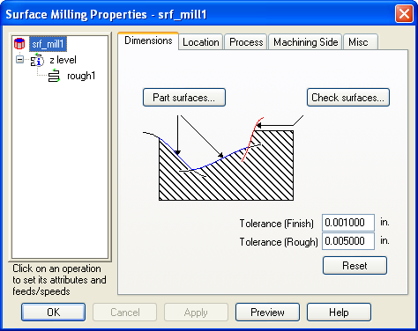
Surface Milling Feature
- General 3-axis milling feature
- Added to New Feature dialog box
- Can cut multiple surfaces with one feature
- Multiple operations created from one feature
- All operations cut in a single setup

Dimensions tab

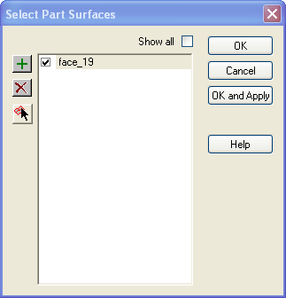
- Part surfaces: surfaces you want to machine in the same way, as the same feature.
- Can pre-select in graphics window before selecting New Feature.
- Select Part Surfaces dialog box shows all visible surfaces.
- Click Show All to show even hidden surfaces
- Must CHECK to include
- Check surfaces: surfaces that must not be machined.
- Boundary up to which milling occurs.
- Tool stops “Check Allowance” from check surface.
- Stock curve opens a dialog box for selecting a curve or curves to limit the machining area. It is important to remember that within a stock curve, the material will be milled away.
- It does not guarantee that milling occurs only within that region.

Location tab
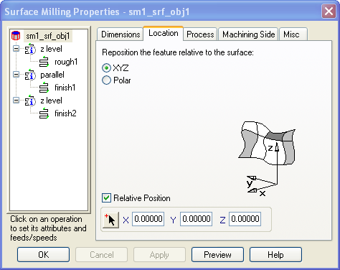
- Position the feature relative to the surface or face.
- Use Polar or Cartesian coordinate system
- Relative position check box orients object with respect to the set up. If unchecked it will be with respect to the stock axis.
- Use the mouse pick to position it yourself or enter in the coordinates.
- The preview button will allow you to see the change before you apply it.

3D Process tab
- Lists Processes and operations for Feature
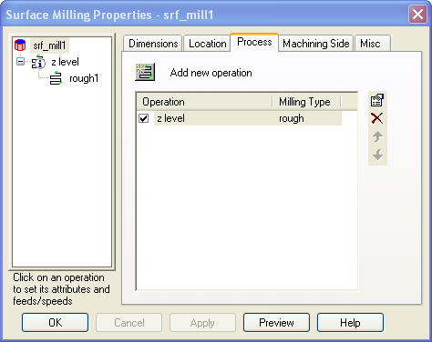
- Operations can be created manually
- All operations created and deleted from Process tab
Add New Operation
Modify Operation
Delete Operation
Move operation up
Move operation down

- Pre-drill adds a drilling operation so the end mill doesn’t have to ramp in to the stock. The point location and size are determined from your tool settings. If you want to specify those explicitly, set the Pre-drill and Plunge points manufacturing attributes in the Milling tab for the specific operation selected in the tree view window pane.
- Edge Protection can take one of two settings to control how the edges of the surface or group of adjacent surfaces in one feature are milled.
- All is a way to protect all edges so that the milling moves around the edges to avoid gouging the surfaces, but may travel beyond the area the surface occupies. Milling outside the surface area occurs most with simple single surface features or features with just a few surfaces. Other edges, such as the outer boundaries of the feature may put the tool beyond the surface or in areas you didn't intend to mill, particularly with the projection milling methods. Even in simple situations, it is best to model the cutting area by specifying check surfaces, other part surfaces and stock curves. These other controls help define the milling behavior so you achieve good results.
- Interior only protects only those edges internal to the surface or group of adjacent surfaces up to the boundary edge. The milling doesn’t move beyond the boundary edge. This is usually the desired behavior where two surfaces meet at an edge or the edge is an internal sharp crease.

Machining Side tab
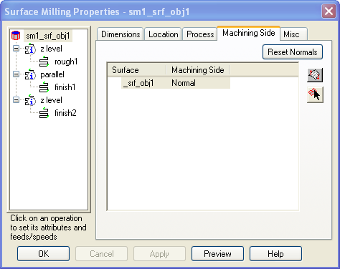
pick surface button and select the surface in the graphics window
Switch machining side
Reset normal allows you to reset to the default machining sides

Solution Sheet
- Open edge.fm. Experiment with edge protection settings.
- Open SM Feature.fm.
- Create a feature with the tube surface. Generate toolpaths.
- Add flat surface as a part surface. Generate toolpaths
- Add “Ball” as a check surface. Generate toolpaths
- Add “curve3” as a stock curve. Generate toolpaths.

3D Groove
- Groove can now have a 3D curve

Exercise
- Open “Surface Trim.fm”
- Offset each surface by 0.25 inches.
- Intersect the two offset surfaces.
- Create a 3D groove using the intersection curve with depth = 0.25.

Chapter 7 - Manufacturing Operations
Chapter
7
Once we have created our Surface Milling Feature, there are many ways to manufacture that feature. This Chapter will explore the different methods of milling that can be used to manufacture the part.

The Flow of 3D milling
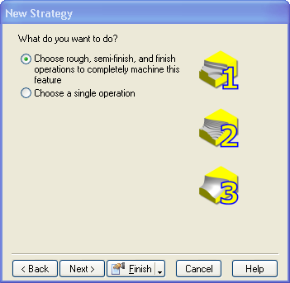
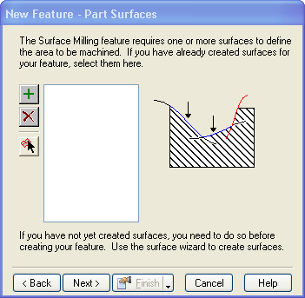
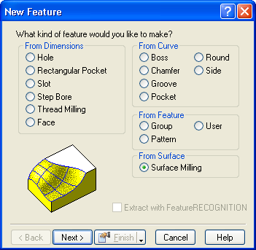
Create the Feature. Pick the surfaces you want to put toolpaths on then pick the types of processes. There is an automatic three operation method that can be used. Or you can control FeatureCAM creating the part a single operation at a time.
Take time to examine the part and look at the surfaces. Ask yourself pertinent questions e.g. How will I hold it? Are there some surfaces that are more vertical than horizontal or vice versa? Is there geometry that is going to be best defined as a 2.5D part?
Assessing these characteristics will make the decision making process easier and more efficient.
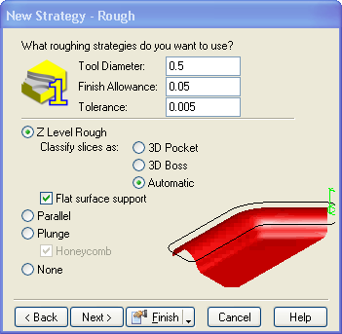
One, Two, Three and you’re Out!( Three operation method)
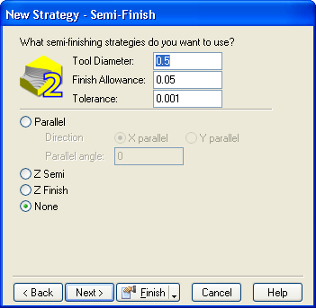
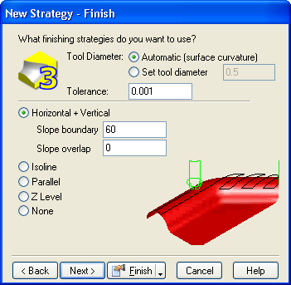
FeatureCAM auto”magically” selects a Rough, Semi-finish and Finish operation with a single radio button. If this is an appropriate method for your part we could already be home by now.
Some parts may not permit you to use a simplified process. Fear not, creating operations one at a time is just as easy.
- Choose single operation
- Select a process you would like to use
- Continue to use the same surface milling feature and add 3D strategies.
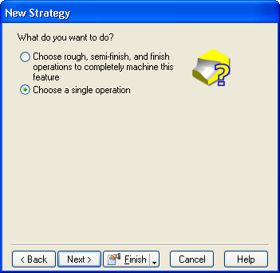

Projection milling methods
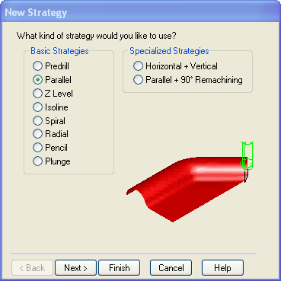
- Two-dimensional pattern of curves is “projected” from the setup to the surface feature
- Predrill becomes active after a feature is created
- Parallel is a pattern of parallel lines.
- Spiral inward or outward spiral is a pattern of curves offset from a stock curve. Inward and outward toggle the direction.
- Radial inward or outward is a pattern of lines that meet at a center point. Inward travels toward the center, outward travels away from the center.
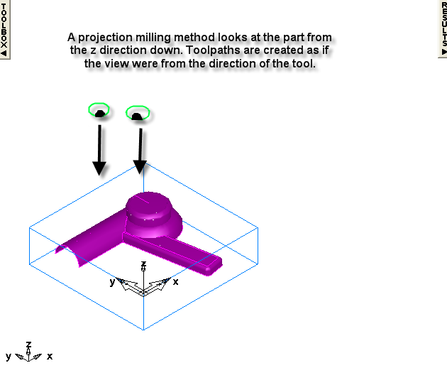
- Isoline guide surface is a hybrid that projects the isolines of the guide surface onto the part surfaces.
- Works across multiple surfaces
- Ignores normals
- Can be used for finishing
- A drawback of projection manufacturing is a non-uniform finish.
- Cusp height is exaggerated in vertical or nearly vertical surface situations. Vertical surfaces are almost invisible to projected manufacturing methods because the vertically projected lines may not detect the vertical surface. The top edge of such a surface is protected, but the actual surface may not be milled. Vertical surfaces might be better candidates for a Side feature instead of a surface.
- Roughing passes can move in X Y and Z.

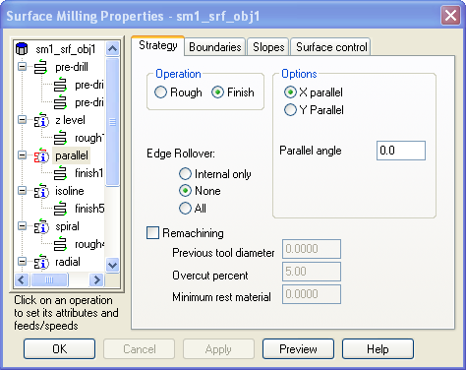
Parallel
- X parallel roughs the feature in cuts that are parallel to the X axis of the current setup.
- You can set an angle that rotates the reference axis for the cuts so you mill at some angle to the X axis.
- The X or Y parallel method, when set with 0 angle, generates smaller NC programs because only two coordinates are needed for any point instead of three coordinates.
- The Y parallel method, when set with 0 angle, generates smaller NC programs because only two coordinates are needed for any point instead of three coordinates.

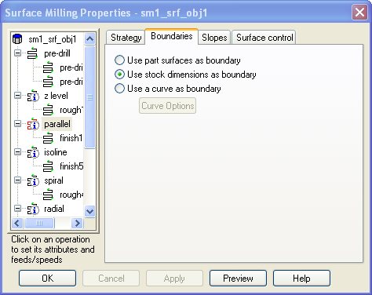
Boundary Control
- Stock boundary is the default
- Use part surfaces (secondary boundary
- Boundary curves can be created and selected
- If using the boundary control it is important to decide where you want toolpaths place
- Select the curve options

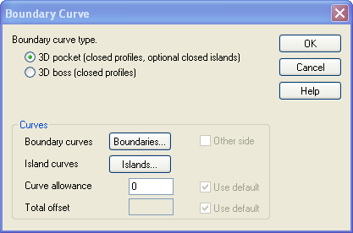
Boundary Curve
- Select curve types Boss or Pocket
- Use curve allowance for tool placement
- Total offset works like total stock

Slopes
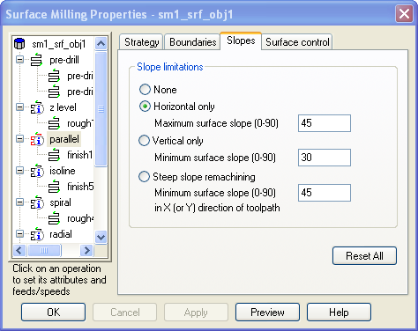
- Controlling the slope can help overcome inherent weaknesses
- The Parallel method has a less than optimum path when cutting on vertical walls.

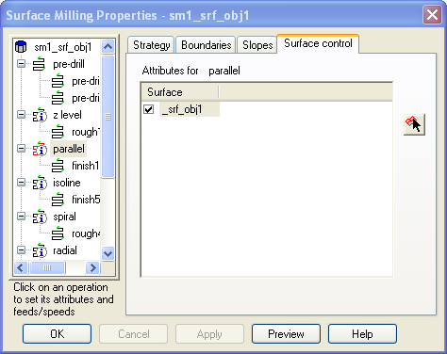
Surface Control
- Select the side you would like to put the tool on.

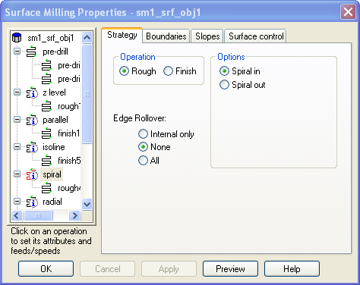
Spiral
- Spiral inward mills the feature in a series of concentric cuts towards the feature center from the block stock outer boundary or stock curve.
- Roughing passes from this milling method can generate three axis tool movements that follow the contour of the surface.
- Stock overcut % attribute is useful for controlling the overlap of boundary. (0% puts centerline of tool on stock curve.)

Spiral Boundary
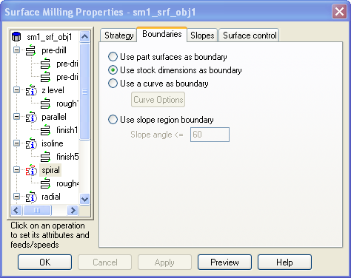
- Spiral is like having the ability to do a 3 dimensional side feature.
- Controlling and defining the proper curve will allow the user more freedom to cut a part.

Boundary curves
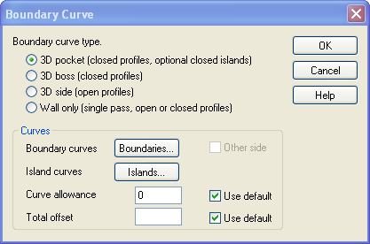
- Spiral
- Curve allowance will let you enter a number equal to the radius of the tool.
- Total offset will start creating paths a set distance away from the curve.

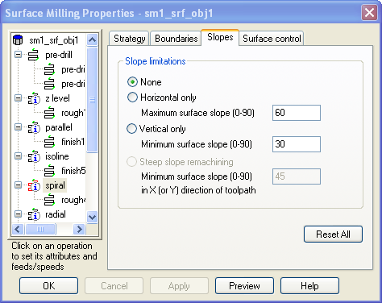
Spiral slopes
- Spiral outward behaves the same as spiral inward except that the toolpaths start in the middle and progress outward.

Spiral out
- Spiral out - toolpaths start in the middle and progress outward.

Spiral in
- Spiral in- behaves the same as spiral outward except that the toolpaths start out and progress inward.

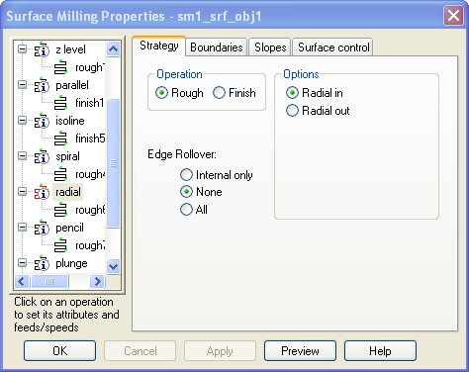
Radial in or out
- Creates moves from center of part radially to boundary.
- Radial inward milling works its way from outside boundary of the feature towards the middle of the feature with each pass.
- Bi-directional rough should be disabled for this method
- The radial term is only a rough description of the actual path as not all feature shapes lend themselves to a truly radial pattern.

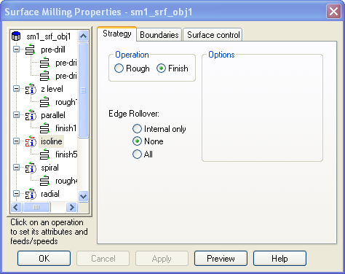
Isoline milling method
- Isoline manufacturing follows the isolines of the surface being manufactured.
- Isoline manufacturing is good for a uniform finish. Because isoline curves track to shape of the surface, the finish is the smoothest of the three methods
- Isoline handles vertical surfaces well. In fact, Isoline is the only way to mill an exactly vertical surface and the best way to finish nearly vertical surfaces.
- Disadvantage: Manufactures each surface of the feature individually.
- Cuts areas where normal is pointing up.
- Setting the Avoid self gouge switch causes FeatureMILL to analyze the toolpaths for self-gouge situations based on tool size and sharp edge situations.
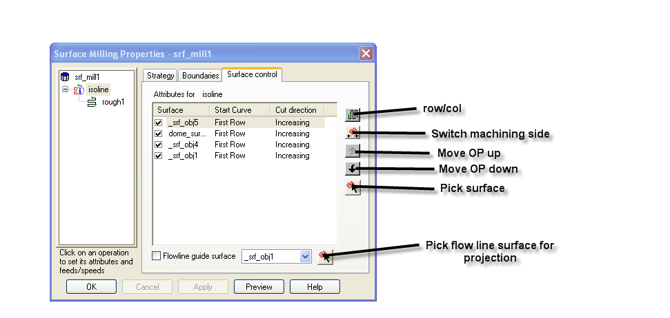
- Isoline control tab

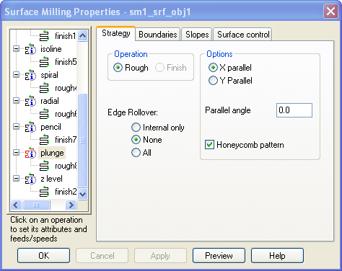
Plunge Milling
- Plunge roughing provides an alternative form of roughing.
- With this technique, roughing is performed with a series of overlapping holes.
- The advantage of this technique is parts can be roughed quickly since the force of the operation is directly up the spindle.

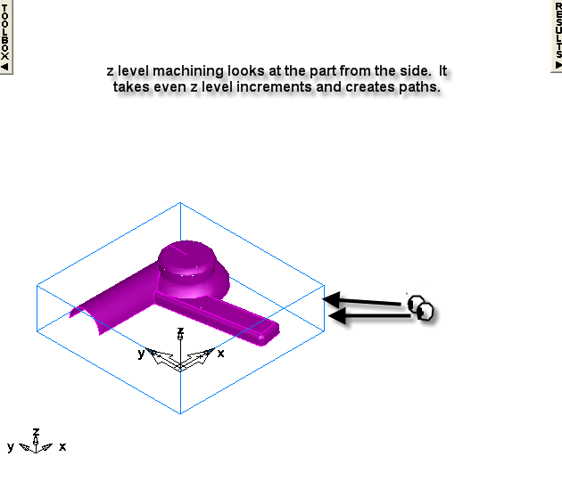
Z-level milling method
- The Z-level method slices the feature at various depths and mills the corresponding 2.5 D pocket or boss shape the surface has at that depth in the feature.

- An excellent roughing technique
- Most like 2.5D milling
- Pocketing is cut well.
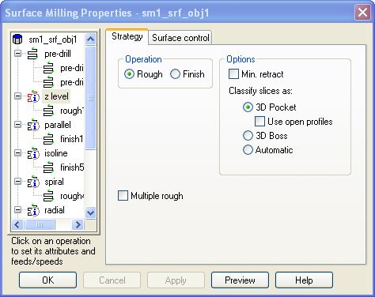
- Advantages over roughing with projection techniques:
- Constant depth of cut with flat surface.
- Best way to rough steep (nearly vertical) surfaces.
- Constant width of cut

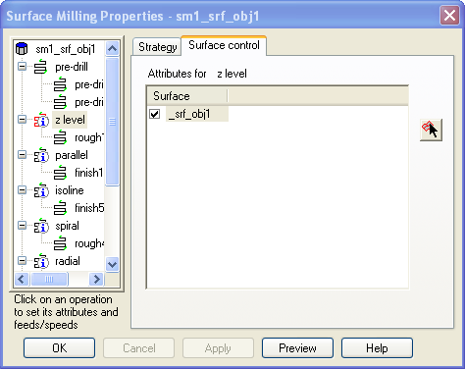
- Z level rough mills features from the top of the current setup down to the feature surface. It removes all the stock material you have defined or set with Total stock, or Stock curves. It makes as many passes as necessary to achieve the depth of the feature.
- There is a useful preview function in the Z level rough operation Milling tab.
- You can limit the area of a surface considered for Z level rough with the Z start and Z end attributes.

Clean up or Clean out?

Limitations of remachining
- Parallel and Remachining operations use projection toolpath techniques and have the same limitations as those techniques.
- Z-level finishing Remachining has the same limitations Z-level finishing.
- Remachining provides approximate boundary curves to limit the machining to the appropriate areas. Spiral operations near vertical walls are not very smooth. In general the Horizontal + Vertical technique is recommended

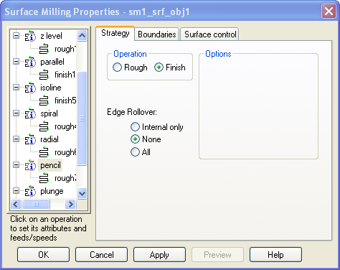
Pencil
Pencil milling operations automatically detect corners less than or equal to the specified radius (including sharp corners) and then creates a single toolpath to clean out these corners. Applications of pencil milling include:
- Finishing fillets in a part with a single toolpath
- Cleaning up sharp concave corners
- Tool needs to touch two walls
- Pre-relieving corners before high-speed finishing the part with a small tool
- Roughing fillets by using the finish allowance.

Solution Sheet – Milling Methods
- Open toolpaths.fm.
- Change toolpath technique to X parallel, Y parallel and Z level roughing.
- Change toolpath technique to Spiral and Radial.

Recommended Machining Strategies

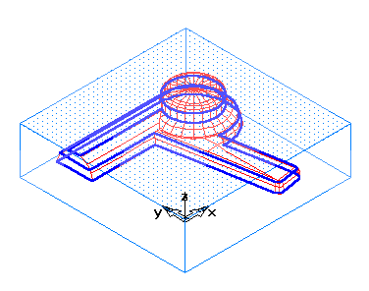Roughing Well-trimmed Models
These models should have well-defined cross-sections when sliced so Z level rough is the recommended technique.
- Rough with Z level rough with Flat End tool.
- Z Increment = DEFAULT,
- Stepover = 50%
2. Semi-rough with Z level rough with same or smaller flat end tool.
- Z Increment = 25% of first rough pass Z Increment
- Total stock = finish allowance (if using same roughing tool ) or rough stepover distance (if using smaller tool).

Roughing Sloppy Data or Untrimmed Models
If your data has overlapping surfaces or data that does not slice into good contours, use one of the projective techniques to rough the model.
- 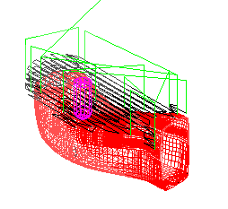Rough with X or Y parallel in longest part direction. Use Flat end tool
- Z Increment = DEFAULT.
- Stepover = 50%.
- Semi-rough with X or Y parallel finishing perpendicular to roughing direction. Use Flat end tool.
- Z Increment = leave Blank.
- Stepover = 50%.

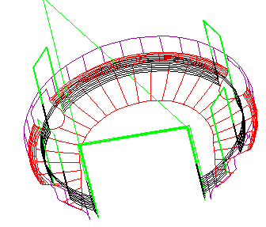Finishing Nearly Vertical Walls
Projection techniques work on the part of the surfaces that are visible from above. As a result, these techniques are not optimal for vertical walls.
- Finish using Iso-line milling with direction perpendicular to vertical

OR
- Finish using projective technique with Stepover = Small Value (sometimes as small as 0.0005) and restrictive stock curve.
- Finish using isoline with flow-line guide surface.

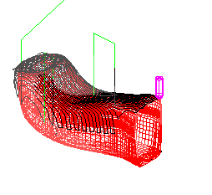Finishing Large Imported Files
Imported files often have hundreds or thousands of surfaces. Since iso-line finishing works on a surface-by-surface basis, it may cause inefficient toolpaths. Therefore, it is recommended that you use projection techniques for these models.
- Finish with X or Y projection using larger ballend.
- Stepover = about 2% of tool diameter
- 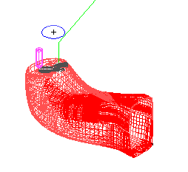Tolerance = small ( as small as 0.0001)
- Finish in regions with smaller detail using X or Y projection using smaller tool (determined using curvature analysis) in a different direction from step 1.
- Use stock curve to limit extent of toolpaths.
- Stepover = about 2% of tool diameter
- Tolerance = small ( as small as 0.0001)

Finishing Large Imported Part with Irregular Shape
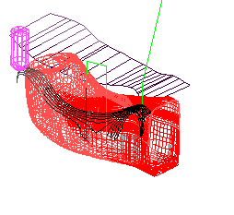Some shapes do not line up well with constant X or Y direction, but you still want to use a projection technique that will work across all surfaces.
- Create a flat surface above the part that mimics that overall shape of the part.
- Finish with Iso-line milling
- Set flow-line guide surface to the flat surface that you created.

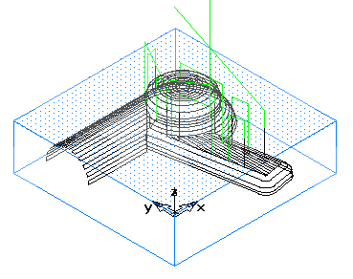Finishing Smaller Models Created in FeatureMILL
Models created in FeatureMILL typically have fewer surfaces than imported data. You also have a better chance of created a well-trimmed model. Iso-line milling is recommended since it will give you the best surface quality
- Finish with isolines using the longest direction of each surface.
- Tolerance = 0.0001
- Scallop height = 0.001

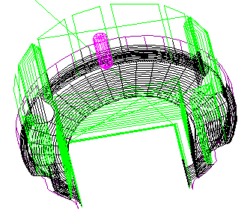Finishing bowls
Bowls combine flat bottoms with steep side walls. X and Y parallel techniques should be avoided if possible.
- Finish using Iso-lines if there are not too many surfaces.

OR
- Finish with Spiral pattern.

3D Tools tab
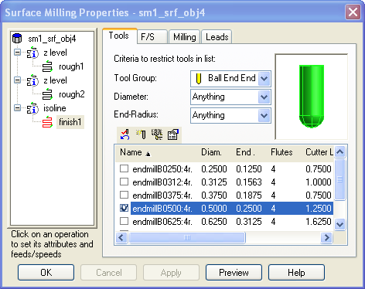
- Tools are automatically selected for Surface Milling.
- Diameter sets a specific value for the tool diameter. The override checkbox sets itself. If you uncheck the override box, the tool diameter is no longer overridden and FeatureMILL uses the default tool.
- End radius of the tool.
- Speed determines how fast the tool spins in RPM. You can set a specific value if you wish. The override checkbox sets itself. If you uncheck the override box, the speed is no longer overridden and FeatureMILL selects the speed to use.
- Feed determines how fast the tool moves through the stock. You can set a specific value if you wish. The override checkbox sets itself. If you uncheck the override box, the feed is no longer overridden and FeatureMILL selects the feed to use.
Reset all clears any overrides you made to the tool selection and feed and speed.

3D Milling tab and Manufacturing attributes

Switches
FeatureMILL analyzes the toolpaths for self-gouge situations based on tool size and sharp edge situations.
Bi-directional sets the operation to mill in each direction. You can combine this setting with Climb Mill to force the first pass to be a Climb mill cut.
Boss is available only for Z level rough operations and is a tri-state checkbox. Checked ON, FeatureMILL mills outside the Z level slice curve. Checked OFF, FeatureMILL mills inside the Z level slice curve. In the GRAY state, FeatureMILL analyzes the surface and its normals to decide whether to mill one side or the other.
Climb Mill sets the operation to use climb milling. When set in conjunction with Bi-directional milling, it ensures that the first pass will climb mill.
Improved uses a finer algorithm to approximate the feature boundary, but takes longer to compute. You can combine this switch with any of the other settings.

Attributes
- Check allowance sets the minimum distance that the tool must remain from the check surfaces. If set to a value, that absolute value is used for both passes. If left blank:
- For a roughing pass the Check allowance = finish_allowance + leave_allowance for roughing
- For finishing the Check allowance = leave_allowance
- Leave Allowance: The amount to leave after a finish pass.
- Normally set to 0
- Can be set to a negative number up to –tool radius for shrinkage or spark gaps
- Stepover: Planar step over distance for finishing with projection techniques
- Typically, set to 0.005 for finishing.
- Scallop Height: Surface scallop height for Iso-line milling.
- Measured along surface not projection plane.
- Parallel angle is available only in X and Y parallel roughing and sets the angle the roughing passes occur in reference to the X or Y-axis. This value can be anywhere from -360 to 360 degrees. A positive value rotates counterclockwise from the axis, and a negative value rotates clockwise from the axis.
- Stock curve acts similar to a stock curve for the feature, but instead of defining the area to mill away for a feature, Stock curve here sets the area that will be milled away for a specific operation. Stock curve only ensures that the area within the curve is milled away. It does not mean that the tool won’t move or cut in regions around the curve. When coupled with the Stock curve overcut % the tool paths behave slightly differently.
- Stock curve overcut % is used in conjunction with Stock curve and specifies what percentage of the tool radius passes beyond the stock curve boundary. Stock curve overcut % of 0 puts the centerline of tool on stock curve. Stock curve overcut % of 100%, will overcut the region by the tool radius
- Tolerance sets how close the milling will be to the mathematically ideal surface. This does not guarantee that your feature is machined to this tolerance in all locations if the tool you select is incapable of cutting within that tolerance in constrained areas. If your part shows a faceted appearance, set your tolerance to a lower value.
- For finishing set to 0.0001.
- Z end sets the distance along the Z-axis below which the operation will not mill. You may want to use Z end on an earlier operation then follow it with an operation using the Z start attribute so you control the toolpaths efficiently.
- Z increment sets the distance the tool moves down in the Z-axis with each pass.
- Z start sets the distance along the Z-axis where the milling operation will start. You can use this to save time in manufacturing if the stock material has already been machined away in an earlier operation.
- Finish Allowance amount of material left after roughing pass. If you have multiple roughing operations defined, the finish allowances are all absolute and are not automatically added together.

